**Valley Beat**

**Newsletter**



**Issue: November 2023**

**Your Local Team**

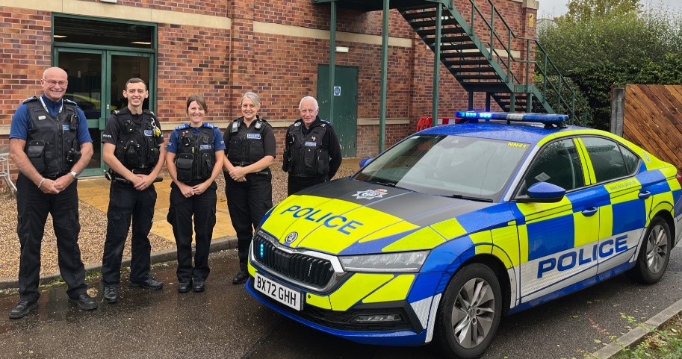

Your Dedicated Neighbourhood Team (DNT) is a group of local police officers dedicated to serving your community. The team is made up of officers based in your area, supported by the wider Policing family.

* PS 4107 Gary Sirrell
* PC 70 James Martindale
* PC 2238 Riannon Simpson
* PCSO 6517 Tony Gallagher
* PCSO 6178 Nicola Russell
* PCSO 6683 Pat McDonald

**What matters to you**

Through Neighbourhood Link, social media and local engagement events, we have listened and will be prioritising the following in November 2023.

**Priority 1: Speeding within Worthington**

*You Said: That speeding was an issue around the vicinity of Worthington.*

*What we are going to do:* *Increase patrols and carry out speed enforcement operations in the area.*

***Priority 2: ASB at the Great House, London Road, Kegworth.***

*You Said:* *The abandoned building on London Road, was being targeted by ASB.*

*What we are going to do:* Increase patrols to target harden and prevent ASB at the location. Identify offenders and educate to prevent further occurrences.

**Priority 3: Dwelling burglaries in the NN43 Beat area.**

*You Said:* Burglaries taking place on the Valley Beat.

*What are we going to do:* All burglaries to be attended, with forensic opportunities exploited. House to house, and proportionate CCTV trawls to be done. All avenues to be considered to give advice to residents to help 'target harden' and deter thieves away from the NN43 Beat area. Patrolling will be done by the Beat team with a view to catching and convicting those responsible.

**Page 1 Valley Newsletter**

**Page 1 Valley Beat Newsletter**

* Officers have conducted a speed enforcement operation around North-West Leicestershire, including sites in Castle Donington (Namely the new bypass) and Worthington.
* We conducted high visibility patrols during peak times at the Wakes, Castle Donington.
* We’ve dedicated a lot of time around our three new priorities, as above. Including patrolling, target hardening and educating.
* Enforcement continues into the weekly car cruise, further Section 59 reports and traffic offence reports issued.

**What we are doing**

**Crime Trend and Figures**

**Protecting your home - Checklist for securing your home when you leave it**

We are seeing an increase in burglaries across the whole of NW Leicestershire. It’s vital to leave your home secure whenever you leave it. Getting into an ‘exit routine’ can help ensure that you don’t forget obvious, important things, like not leaving your valuables near windows, or no lights on if it will be dark before you get home. Here’s what you should do just before you go out.

**Here’s what we recommend you do before you go out:**

* close and lock all your doors and windows, even if you’re only going out for a few minutes
* double-lock any door
* make sure that any valuables are out of sight
* keep handbags away from the letterbox or cat flap and hide all keys including car keys, as a thief could hook keys or valuables through even a small opening
* never leave car documents or ID in obvious places such as kitchens or hallways

**Here are five tips to help you keep your home and belongings stay safe while you’re away:**

* if you’re off on holiday and wish to post anything on social media, make sure your posts aren’t public and that they’re only seen by your friends
* leave lights and a radio on a timer to make the property appear occupied
* get a trusted neighbour to keep an eye on your property or join a Neighbourhood or resident Watch Scheme
* consider asking your neighbours to close curtains after dark and to park on your drive
* remember to cancel newspaper and milk deliveries

**To find out about crime that occurs within your area, please click on the link below.**

<https://www.police.uk/pu/your-area/leicestershire-police/valley/>

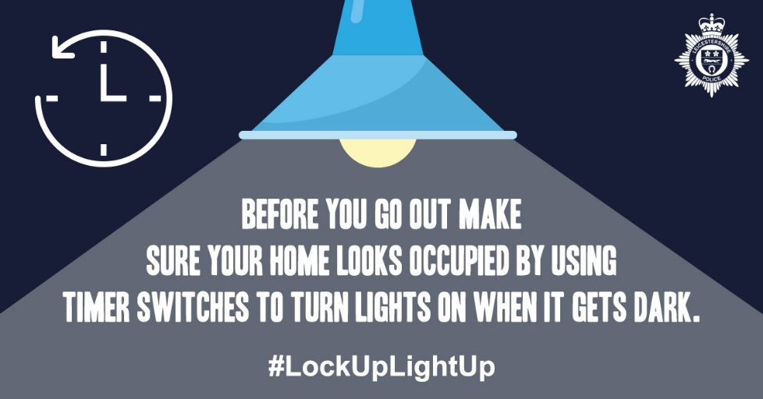

**Community Engagements**

**Page 3**

**Don’t miss out on our events:**

***Drop in at Kegworth Village Hall***

* 12:00PM – 13:15PM /Wednesday 8th November2023
* Village Hall, Nottingham road, Kegworth, DE742FH

***Beat team engagement event on Main Street, Wilson***

* 10:00AM – 11:30AM / Saturday 18th November 2023
* Bulls Head Public House, Wilson, DE731AD.

***Drop In at Long Whatton Stores***

* 10:00AM – 11:00AM / Tuesday 21st November 2023
* Long Whatton Stores, Main Street,

Long Whatton, LE125BH.

***Village event at Borough Street, Castle Donington***

* 02:00PM – 03:00PM / Friday 1th December 2023
* Christmas Cheer, Borough Street, Castle Donington,

DE742LA.

***Drop in at Sawley Marina, Sawley***

* 10:00PM – 12:00PM / Saturday 2nd December 2023
* Sawley Marina, Sawley, NG103AE.

***Village event at Market Place, Kegworth***

* 12:00PM - 13:00PM, Saturday 3rd December 2023
* Christmas Market, Market Place, Kegworth, DE742EE

**Contact us**

**NEIGHBOURHOOD LINK:**

Neighbourhood Link is a community messaging service from Leicestershire Police that provides news and information about policing activity or initiatives, crime prevention advice as well as major incidents affecting your area. In order to receive messages, you will need to register your details. Registration is free and simple to follow.

• Sign up at: <https://www.neighbourhoodlink.co.uk>

• Already have an account? Simply request a reminder if you have forgotten your username or password

• You can unsubscribe from the service at any time

Neighbourhood Link is not able to receive messages and you should not use it to contact the police. In an emergency always dial 999. If you wish to contact Leicestershire Police in other circumstances, for example to speak to local police or seek advice on police matters, you can call us by dialling 101 on your telephone or using any of the below sites.

Please also take the time to let the Valley Beat understand your concerns by completing the surveys to the right. Simply scan your camera over the top and click the link.



Your Views Survey



Confidence Survey



**@NWLeicsPolice**

**Leics.Police.uk**

**North West Leicestershire Police**

**Northwest.lpu@leicestershire.pnn.police.uk**