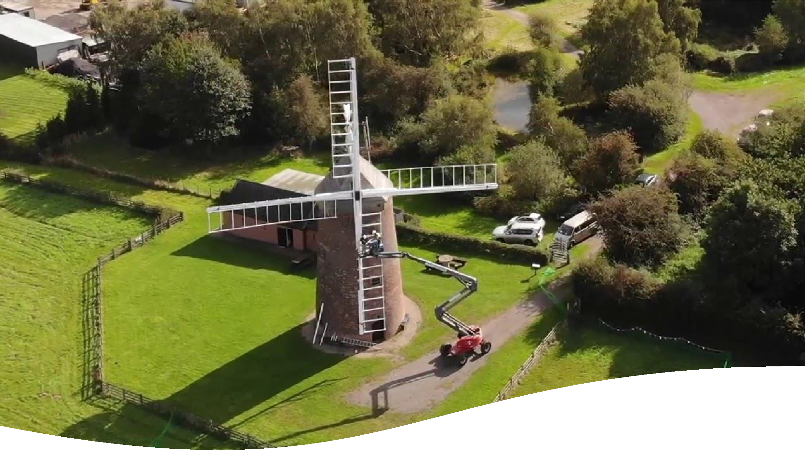

Swannington Parish
Neighbourhood Plan

Pre-submission version
June 2021

INTENTIONALLY BLANK

CONTENTS
Page
Foreword 4
- About this Neighbourhood Plan 5
- The Consultation Process 9
- A Plan for Swannington Parish 10
- Housing and the Built Environment 13
- Environment 23
- Community Sustainability 42
- Monitoring and Review 51

Appendices
Census Data A
Land Registry Data B
Site Sustainability Analysis C
Housing Needs Report D
Affordable Housing for Sale Report E
Environmental Inventory F
Local Green Spaces: evidence base G
Statutorily protected heritage assets: Listed Buildings H
Views I

Foreword from Chair of Advisory Committee
The Localism Act 2011 gave residents the power to shape the future of their communities by putting neighbourhood plans at the heart of a new planning system. Under the Act, councils and local people are able make decisions about the impact of many aspects of future development, its design and location.
Swannington Parish Council made the decision to embrace these new powers and to draw up the ‘Neighbourhood Plan’, which will help to direct development across the whole parish over the lifetime of the Development Plan (up to 2031). Provision is made for the Neighbourhood Plan to be kept ‘live’. It will be regularly monitored and formally reviewed every 5 years or whenever there is a significant change in the Development Plan.
Our Neighbourhood Plan provides a local framework for future development, which must be taken into account when planning applications in the Designated Area are determined. It has been compiled by local residents and a Neighbourhood Plan Advisory Committee as a formal committee reporting to the Parish Council. I wish to thank all those who contributed and in particular the members of the Advisory Committee
Neighbourhood Plans are required to be in general conformity with the strategic policies of the Local Planning Authority and the Government’s National Planning Policy Framework (NPPF) 2019.
The preparation of our Neighbourhood Plan has seen many local consultations and surveys. The Advisory Committee has met regularly, although via Zoom during the pandemic, welcoming the public to its meetings when possible and directing the work of separately established Theme Groups, whose role it has been to develop the policies that are appropriate and meaningful to the people who live and work in our community.
The Plan, as a statutory document, will give residents a real influence in decisions on the location, character, sustainability and scope of new development and recognises the community’s aspirations.
The Neighbourhood Plan is a legal document that forms part of the statutory Development Plan for the District. Planning decisions by North West Leicestershire District Council will be made having taken the Plan into account. Our policies, as stated in the Plan, will take priority over nonstrategic policies in the Local Plan, giving our community a real and lasting tool to influence the future of our neighbourhood.
Roger McDermott
Chair, Neighbourhood Plan Advisory Committee, June 2021

1 About this Neighbourhood Plan

Background
Neighbourhood Plans give local communities a much greater opportunity to influence future development in their areas. The NPPF is the Government’s ‘bible’ on planning issues. It states that ‘Neighbourhood planning provides a powerful set of tools for local people to ensure that they get the right types of development for their community.’
The Swannington Parish Neighbourhood Plan will sit alongside, and be aligned with, the North West Leicestershire Local Plan. It cannot undermine its strategic policies contained within the Local Plan or the Leicestershire Minerals and Waste Local Plan. Other than that, the Swannington Parish Neighbourhood Plan is able to shape and direct sustainable development in the Parish. Once approved, the policies it contains will take precedence over non-strategic policies in the Local Plan.
On 7 January 2019, North West Leicestershire District Council approved the Parish Council’s application for designation as a Neighbourhood Plan area. The area to be covered by the Plan is defined by the Parish boundary (see Figure 1).

Neighbourhood Plan Advisory Committee
The Neighbourhood Plan Advisory Committee was fully established by the Parish Council and held its inaugural meeting on 11 March 2019. This group comprises both Parish Councillors and other volunteers from the community. The Committee members were approved by the Parish Council and given the authority and responsibility to deliver the Plan. The Group worked hard to drive the process forward, assisted by Your Locale Neighbourhood Plan consultancy.
Theme Groups of local volunteers were formed through the process of delivering the Neighbourhood Plan to draw up policies that will inform and guide the future development within the Plan. They focussed on the following Themes:
- Housing and the Built Environment
- The Natural and Historic Environment
Community Sustainability issues were dealt with by the Advisory Committee as a whole.
The groups were guided by facilitators provided by YourLocale. They reported back to the Advisory Committee, met regularly and gathered information to support the formation of the emerging Neighbourhood Plan policies. Much of the information, which supported the decisions and provided evidence bases, has been gleaned from the extensive research, consultation and local knowledge of the group members.

Figure 1 – Neighbourhood Area. Designated on 7 January 2019
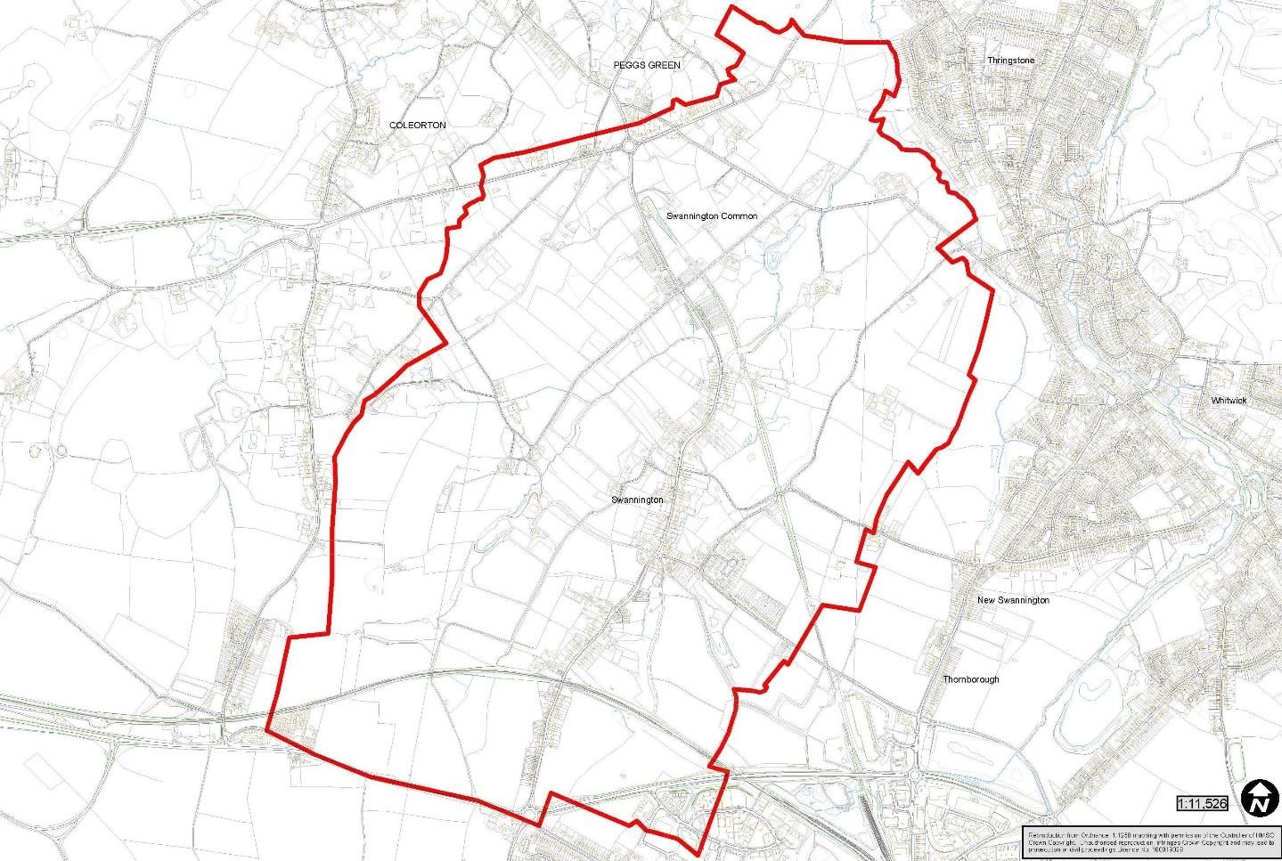

Swannington Parish

Located in North West Leicestershire between Ashby-de-la Zouch, Coalville and Loughborough, the village is accessible from three main points, Peggs Green Island on A512, Hoo Ash Island on A511 (the stretch from island to island being approximately 1.25 miles long), and via Spring Lane, accessed from Coalville before joining the main route through Swannington near the Robin Hood Pub at the junction where Main Street becomes Station Hill. Another access point leading on and off the main route through is known as Jeffcoats Lane, Limby Hall Lane crossroads, the crossroads is located where St Georges Hill leads into Main Street. An additional way into the village is from the east along Church Lane, although this is narrow and twisty.
Swannington’s heritage/history is linked to mining activity going back at least 800 years. The underlying coal measures meant that there were probably hundreds of bell and gin pits in the village and evidence of these pits remains in the Gorse Field off St Georges Hill. With the advance of technology, there were also deeper pits in Swannington and surrounding area. These were serviced by numerous shafts which are located through the village. The Califat mining excavations off St Georges Hill show the footprints of the former mine buildings. It is this mining activity which has given the village its numerous public footpaths enabling the mining community of that time in history to take a shortcut, accessing their working mines.
These public footpaths are still walked in the 21st century by visiting walking groups to the area and has frequent use by local dog walkers and families for health and wellbeing benefits. The public footpaths cross natural countryside, farmland and go through woodlands, part of the National Forest. The village is also famed for its heritage linked to the Swannington Incline, designed by
Robert Stephenson, which connected Swannington to Leicester via the first steam railway in the Midlands and provided an efficient means of getting coal from the pits in and around Swannington to the market of Leicester. Other historically interesting features include Hough Mill plus other historical buildings through the village.
Village amenities include the Church with graveyard overlooking Swannington village from the top of Church Hill and the Village Institute built in 1931 for the miners social events (referred to now as the Village Hall). The Village Hall is in the middle of the village, offering rooms and hall for activity and social groups with several off-road parking spaces available.
Swannington Primary school (CofE) has school playing fields and playground, was built in 1862 and is attended by children from within the village and other surrounding areas, with drop off and collection parking takes place along Main Street. Swannington has two pubs, plus one Indian restaurant previously a butcher shop converted approximately seventeen years ago. Historically, originally a co-op store before conversion to the butchers.
A sports field is located on the corner of Jeffcoats Lane owned by Wyggeston Hospital Trust. Four allotment sites are noted within Swannington Village, three run by the Parish Council. All sites are owned by Wyggeston Hospital Trust.
Swannington Heritage Trust promotes the history and heritage of the village. This charity owns and maintains five sites plus a large village archive. The volunteers aim to keep the heritage of the village alive for all age groups and offer numerous events and volunteering opportunities. Swannington Open Gardens promotes community engagement via horticultural and social activity to benefit chosen charities from fundraising activities.
Fields can be seen at Spring Lane, Hough Hill and St Georges Hill - entry points to the village thus providing a boundary between local towns and villages. Large housing developments are in nearby Whitwick. Fields are also alongside the incline; behind properties on Main Street including the Village Hall; adjacent to a farm property presently for sale (at time of writing this draft report). Fields at the A512 end of the village have historical connections to the mining and Tunnel which collapsed under Peggs Green Island in the 1960’s.
Another distinct character of the village are its narrow lanes, and potentially hazardous junctions some made difficult by parked cars, limited passing places, speed and volume of traffic going through the village as evidenced by speed watch run by Swannington Parish Council.

Census 2011 information
At the time of the 2011 Census, Swannington was home to around 1,270 residents living in 583 households. Analysis of the Census suggests that between 2001 and 2011 the local area population increased by around 10% (119 people). During this period, the number of dwellings rose by 19%
(98).
There is evidence of a higher than average representation of older residents living in the local area with 19% of residents aged 65 which is higher than the borough, region and national averages. There is also evidence that the population is ageing with the share of residents aged 65 and over increasing from 17% of the total population in 2001 to 19% in 2011. The Census shows that the number of residents aged 65+ rose by 25% during this period. In line with national trends the local population is likely to get older as average life expectancy continues to rise.
Home ownership levels are around 74% of households owning their homes outright or with a mortgage or loan and at 8% the share of households living in social rented accommodation is low when compared with borough, regional and national rates.
There is evidence of under occupancy, suggesting a need for smaller homes of one to two bedrooms which would be suitable for residents needing to downsize, small families and those entering the housing market. Providing suitable accommodation for older residents will enable them to remain in the local community and release under-occupied larger properties onto the market which would be suitable for growing families.
There is a predominance of older terraced housing and an under representation of housing for single people with just 5% of dwellings having one bedroom.
Land Registry and council tax data indicates there has been very little new build housing market activity over recent years.
Deprivation is not a significant issue in the local area but the area’s relatively high ranking in the Living Environment domain of the 2015 Indices of Deprivation, which may reflect the older type of housing in the local area and a higher than average proportion of dwellings without central heating.

2 The Consultation Process
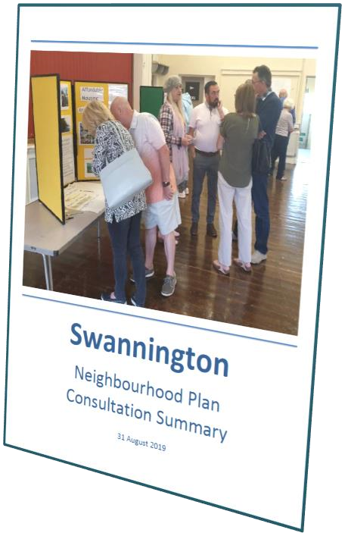
The Neighbourhood Plan Advisory Committee’s mandate was to drive the process, consult with the local community, gather evidence to support emerging policies and prepare the Plan for consideration and ultimately approval by Swannington Parish Council. A detailed chronology of the approach to consultation and the outcomes is contained within the Consultation Statement that is included with the Submission Neighbourhood Plan.
A community questionnaire produced in the autumn 2019 represented the comments of 103 residents of the Parish, a return of 20% of the adult electorate, and this helped to identify some of the key issues that would need to be addressed through the Neighbourhood Plan.
The Advisory Committee also gathered statistical information about the parish from a range of sources to provide a body of evidence on which to base the Plan’s emerging Policies.
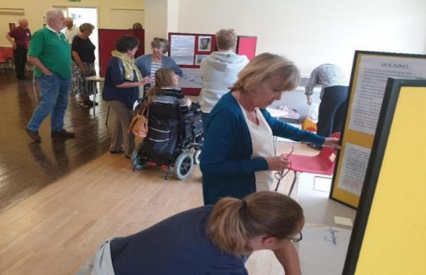
An open event took place on 31 August 2019 which was attended by 63 residents. This provided an opportunity for people to comment about what should be included in the Neighbourhood Plan and to explain the process.
Open Event 31 August 2020

From October 2019 onwards, ‘Theme Groups’ were formed of members of the Advisory Committee along with other residents and stakeholders. The groups met over the following 6 months and gathered the evidence
needed to progress ideas and to formulate policies.
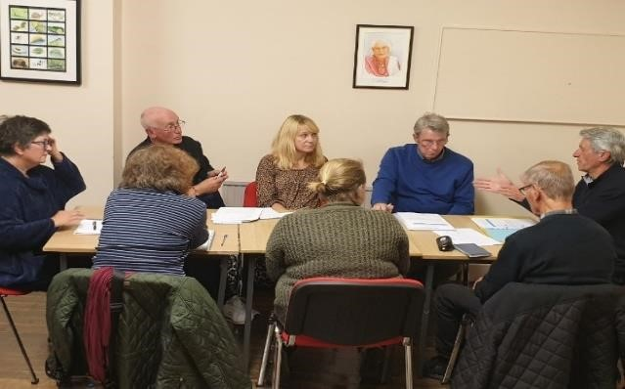
These groups undertook a range of work including field surveys and data analysis in order to build the content of the Neighbourhood Plan and to ensure that the evidence gathered was robust.
Theme Group Launch 9 October 2020

The Neighbourhood Plan was developed from these discussions, from all the other consultations and interviews conducted by members of the Advisory Committee and from research and evidence collected.

3. A Plan for Swannington Parish
The policies of the Swannington Neighbourhood Plan are set within the context of the plan-making framework for England. The scope and content of the Swannington Neighbourhood Plan has been shaped by the priorities and aspirations of the local community, led by the Parish Council’s Neighbourhood Planning Advisory Committee. This Plan covers the period up to 2031.
In drawing up this Plan, the following vision and objectives have been prepared:

A Vision for 2031
By 2031, our aim is to:
- Maintain the balance between Swannington’s natural and residential environment.
- Develop infrastructure regarding road and footpath safety, also improve public transport links.
- Encourage housing which enhances the landscape and street scene and which addresses the priorities identified by Swannington Residents.
- Promote and encourage any social hub scheme needed in the village
- Promote community areas which address age and gender needs
- Develop a community information scheme through publications and to work alongside the Parish Council website.
- Encourage local employment and business initiatives which serve village requirements.
Above all else we intend to promote inclusivity in all matters regarding the present and future population, who choose to live and contribute to the village of Swannington.

Objectives
The vision will be achieved by:
Housing - Recognising the importance of new homes required by Swannington that meet the needs of the Neighbourhood Plan without distracting from the character of the village and its natural, rural location and heritage uniqueness.
Economy - Promoting new economic, employment, bespoke, niche, crafting opportunities in appropriate locations. Also encouraging the retention of existing employers in our Village.
Amenities - Developing local facilities for existing and new residents of Swannington.
Built Environment – Prioritising local distinctiveness in every element of change and growth. Incorporate Local Connection Policy to ensure appropriate housing is available to Swannington residents.
Natural Environment - Safeguarding our natural environment and enhance biodiversity through sensitive development, which protects and enriches the landscape.
Infrastructure - Seeking on-going improvements to transport and parking, to utility infrastructure and to digital connectivity especially mobile phone reception and broadband.
Leisure and Wellbeing - Ensuring residents have adequate access and opportunity to open space / recreation, to maintain a strong, active, healthy and vibrant community.

Planning Context
The procedure for the making of a Neighbourhood Plan is prescribed within the Neighbourhood Planning (General) Regulations 2012. The Regulations have informed the preparation of policies for the Swannington Neighbourhood Plan, in particular ensuring that the Neighbourhood Plan:
- Contributes to the achievement of sustainable development.
- Is in general conformity with the strategic policies of the North West Leicestershire Local Plan and Leicestershire Minerals and Waste Local Plan and has regard for the policies contained within the NPPF, as well as meeting a range of EU obligations.

Sustainable Development in Swannington
A definition of sustainable development is provided within the NPPF. It describes three dimensions to sustainable development and that these dimensions give rise to the need for planning to perform a number of roles:

An economic role
Contributing to building a strong, responsive and competitive economy, by ensuring that sufficient land of the right type is available in the right places and at the right time to support growth and innovation; and by identifying and coordinating development requirements, including the provision of infrastructure.
The community of Swannington is primarily residential, but there is a strong desire to safeguard its employment locations, including the farming community. We therefore wish to retain the current level of employment and develop it further where possible and appropriate.

A social role
Supporting strong, vibrant and healthy communities, by promoting the supply of housing required to meet the needs of present and future generations and by creating a high-quality built environment, with accessible local services that reflect the community’s needs and support its health, social and cultural well-being.
The Swannington Neighbourhood Plan does not anticipate more than limited and proportionate residential development over the lifetime of the Neighbourhood Plan. It seeks to ensure that any new housing delivers a mix of housing types to meet the needs of present and future generations and supports the community’s health as well as its social and cultural wellbeing. The provision of bungalows for older people as well as some smaller and more affordable homes would be welcome. We are also seeking to support and enhance existing community facilities and to improve services for younger people.

An environmental role
Contributing to protecting and enhancing our natural, built and historic environment. As part of this, helping to improve biodiversity, use natural resources prudently, minimise waste and pollution, and mitigate and adapt to climate change including supporting the move to a low carbon economy. In order to protect and enhance our natural, built and historic environment, we are seeking to ensure that:
- Special open spaces within the Neighbourhood Area are protected from development, to protect the village identity and retain the rural nature of its surroundings;
- Development preserves and contributes to the attractive local countryside including replacement of any natural boundaries lost, improvement of existing hedging and encouraging new planting;
- Development recognises the need to protect and, where possible, improve biodiversity and important habitats and includes adding hedging to boundaries of new developments

4. Housing and the Built Environment

Housing Provision
The NWLDC Local Plan was adopted in November 2017, using the Housing and Economic Development Needs Assessment (HEDNA) report as its base for calculating need. The Plan notes that the agreed housing need between 2011 and 2031 is for a district-wide provision of 9,620 dwellings. It is estimated that with completions since 2011, sites under construction and with extant planning consents a total of 10,592 dwellings will be delivered by 2031, an excess supply of 972 units. The positive delivery figures are such that with a 20% buffer of the base HEDNA target NWLDC has a supply for more than six years and with a 5% buffer NWLDC has a supply for more than seven years.
The Local Plan establishes a hierarchy of settlements to help to determine the most appropriate locations for development. On the basis of this hierarchy, Swannington is classified as a Sustainable Village. The Local Plan describes Sustainable Villages as ‘Settlements which have a limited range of services and facilities where a limited amount of growth will take place within the defined Settlement boundary’. The Local Plan goes on to say ‘Some development in these settlements will be appropriate, although there is already a significant level of provision made through planning permissions. Any further development in such settlements will be restricted to either infilling or previously developed land which is well related to the settlement concerned’.
There is no specific housing requirement for Swannington over the Plan period.
Notwithstanding the above, the Neighbourhood Plan has undertaken a comprehensive assessment of potential residential development sites in a positive approach to securing sustainable development and to help meet a local need. The process undertaken is detailed in the supporting information (Appendix C).
The outcome of this exercise is that land is allocated for residential development as follows.
Policy H1: The land at St Georges Hill as shown in Figure 2 below is allocated for residential development within the newly designated settlement boundary.
Development will be supported subject to the following conditions:
- The site will be allocated for a minimum of eight units, at least three of which will be
Affordable Housing; and
- The existing planting will be retained and enhanced within a sensitive design solution.
Swannington NDP – DRAFT Planning conditions St Georges Hill (Lower)

- The following conditions are suggested for this site;

Land is allocated for residential development at the site shown at figure X and within the newly revised settlement boundary.
Development will only be permitted subject to the following requirements being achieved:
- The development will provide for up to twelve dwellings in support of policy H1.
- A minimum of at least four of the dwellings will be affordable, the definition of affordable housing is set out at Appendix 1.
- The existing green assets and planting will be retained and improved within a sensitive design solution.
- The construction of bungalows or property designed for elderly and/or disabled people is strongly preferred.
- The design and elevational treatment to the units abutting the village built form will be of a high quality so as not to undermine the setting and be sensitive to the heritage aspects of the site.
- Priority will be given to dwellings of three bedrooms or fewer;
- The development will not create an adverse impact on the character of the area, or the amenity of neighbouring dwellings.
- A footpath and vehicular link will be constructed to Leicestershire County Council’s adoptability standards to St Georges Hill to serve the site.
- The site cannot be subdivided in development or planning terms.

Figure 2: Residential site allocation
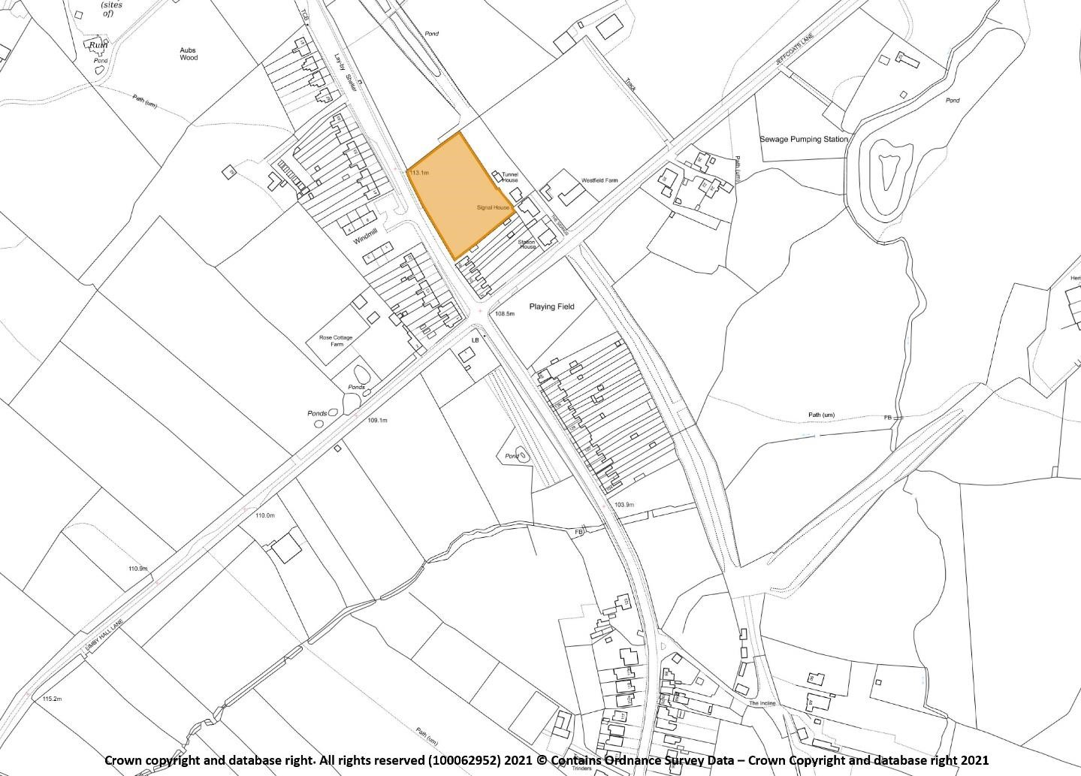

Settlement Boundary

In historical terms rural communities such as Swannington have often been protected by the designation of a village envelope (or settlement boundary) adopted in a statutory Local Plan.
The purpose of the new Neighbourhood Plan settlement boundary policy is to ensure that sufficient land to meet residential and commercial need is available in the most suitable locations. The identified land should be supported by transport links and services infrastructure and avoid encroaching into the countryside unless covered by local and national planning policies.
Settlement boundaries were established by NWLDC in order to clarify where new development activity is best located. They are used to define the extent of a built-up part of a settlement and distinguish between areas where, in planning terms, development would be acceptable in principle, such as in the main settlements, and where it would not be acceptable, generally in the least sustainable locations such as in the open countryside. Such unfettered and/or unsustainable growth would risk ribbon or piecemeal development and the merging of distinct settlements to the detriment of the community and visual amenity of the built-up area.
The Neighbourhood Plan therefore designates the settlement boundary for the built form of Swannington – as shown below in Figure 3. This updates and supersedes the existing Settlement boundary used by NWLDC as it takes into account recent housing allocations and site allocations proposed through the Neighbourhood Plan. Within the defined settlement boundary an appropriate amount of suitably designed types of development in the right location is acceptable in principle, although some sites within the boundary are protected, and all development will be required to take into account the policies within this Neighbourhood Plan.
In statutory planning terms, land outside a defined settlement boundary, including any individual or small groups of buildings and/or small settlements, is treated as countryside. It is national and local planning policy that development in the countryside should be carefully controlled. It should only be allowed where it is appropriate to a rural location, such as for the purposes of agriculture, including farm diversification, or if needed for sport and recreation uses or for affordable housing.
This approach to development in the countryside is supported by the Neighbourhood Plan because it will ensure that any development is focused in the areas which are most needed and least intrusive, making best use of the limited range of services and facilities. The following policy will also help to maintain the special and unique landscape character and setting of Swannington and protect the open countryside for what it is, an attractive, accessible, distinct and non-renewable natural resource.
Methodology:
In designating the actual settlement boundary, the Swannington Neighbourhood Plan will apply the following methodology: Existing physical features such as walls, fences, hedges, gardens, streams, leisure amenities, footpaths and roads will be used to delineate the boundary. Non - residential land which is associated with the countryside, agricultural land or woodland will be specifically excluded. The residential allocation within the Neighbourhood Plan is incorporated within the settlement boundary.
The community has expressed a strong desire to protect what is special about Swannington for future generations. The countryside setting, the high quality of life and the quiet environment are of particular importance.
POLICY H2 - SETTLEMENT BOUNDARY: Development proposals will be supported on sites within the settlement boundary as shown in Figure 3 (below) where the proposal complies with the policies in this Neighbourhood Plan.
Development proposals for the redevelopment or change of use of redundant land or buildings within the village envelope will be supported, provided the site concerned has limited environmental, landscape or ecological value.
Land outside the settlement boundary will be treated as open countryside, where development will be carefully controlled in line with local and national strategic planning policies.

Figure 3: Updated Settlement Boundary
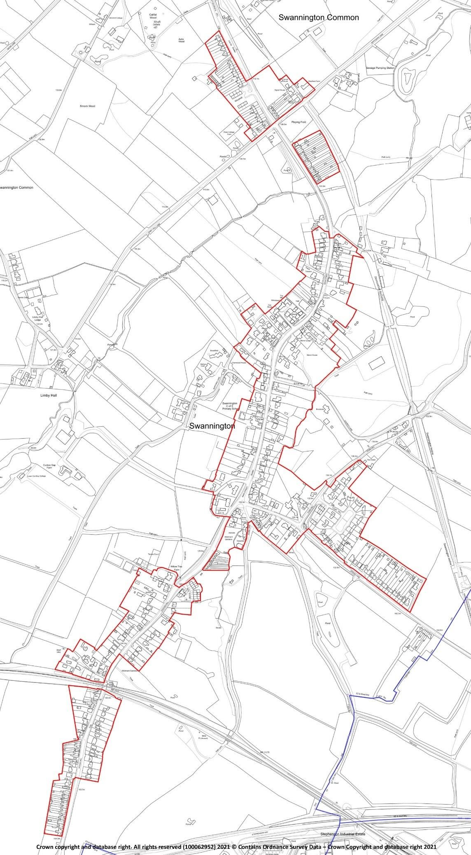

Housing Mix
At the time of the 2011 Census, the average number of bedrooms per household stood at 2.9 which was higher than the region (2.8) and England (2.7) rates. Home ownership levels are high with around 74% of households owning their homes outright or with a mortgage or loan. This is higher than the district (72%), regional (67%) and national (63%) rates. Around 8% of households live in social rented accommodation which was lower than the district (14%), regional (16%) and national (18%) rates.
Around 25% of households live in houses with four or more bedrooms which is above the borough (23%), regional (20%) and national (19%) rates. There is an under representation of housing for single people with just 5% of dwellings having one bedroom against 6% for the borough, 8% for the region and 12% for England as a whole.
There is evidence of under occupancy (more bedrooms than the notional number recommended by the bedroom standard). Analysis of the 2011 Census shows that around 45% of all occupied households in Swannington have two or more spare bedrooms and around 43% have one spare bedroom. Under occupancy is higher than the regional and national averages and is particularly evident in larger properties with more than half (55%) of households with 4 or more bedrooms occupied by just one or two people. This is above district (44%), regional (43%) and England (41%) rates.
Census data also suggests that older person households are more likely to under-occupy their dwellings. Data from the 2011 Census allows us to investigate this using the bedroom standard. In total, around 53% of pensioner households have an occupancy rating of +2 or more (meaning there are at least two more bedrooms that are technically required by the household) and is somewhat higher than the 41% non-pensioner household rate.
In the community questionnaire from summer 2019, the most popular choices for new homes was up to 3 bed (84%); eco-friendly (73%) and ‘small downsizing (68%).
POLICY H3: HOUSING MIX - New housing development shall provide a mixture of housing types which meets identified current local needs in Swannington Parish. Development incorporating new dwellings of three or fewer bedrooms and/or single storey accommodation suitable for older people will be supported, whilst dwellings of four or more bedrooms will be supported only where they are subservient in number to any one, two or three-bedroom accommodation in any development

Design Quality
Along the main route through the village, St Georges Hill, Main Street, Station Hill and Hough Hill, housing comprises properties linked with the heritage and history of the village, some dating back to 13th century, some receive Grade 11 listing. Other styles are terraced properties/dwellings dating back to early 18th/19th century and have no off-road parking facilities. Council housing style properties possibly dates to late 1940’s where a few of these proprieties have now converted their front garden to accommodate off road parking. Other styles include farmhouses with land adjacent, detached and semi-detached 18th century Georgian and Victorian properties with limited parking facilities.
Converted business properties such as post offices of which there has been two at different locations and periods of the village’s history however, the village no longer has this facility; the latest post office was converted for full time residential use approximately ten years ago. Other properties converted to residential dwellings within the past 10 years are a Methodist Chapel and in 2019 a joinery workshop with an adjoining cottage. At the time of writing this draft report the latter property is not fully renovated January 2020). Within the past twenty-five years or thereabouts, another chapel (Wesleyan built 1909) building on Main Street changed its use to become residential from previously being a business premises latter part of 1900’s. These last three properties have either limited or no off-road parking.
Staying with the main route, properties/dwellings (1940’s onwards to present day) consist of detached and semi-detached individually styled bungalows. Other dwellings are modern individually styled detached three – four bedroomed properties.
Recent housing development (since 2015) are three sites all on Main Street. one development converted an old pub to one dwelling plus its car park having three new builds with off road parking to each property.
The two other development sites are in the middle of the village entrance to the site on Main Street completed at the end of 2019, comprising three, four and five bed dwellings with off road parking for two cars per property. The other site also has its entrance coming off Main Street, comprises of two large detached dwellings with off road parking. The first site consisting of three to six bedroomed dwellings derived from demolishing a bungalow with a large garden, whereas another site utilised a large rear garden linked to a Grade 11 property. A further infill property was also completed end of 2019, being built on a plot of land accessed via Main Street with off road parking made feasible via a vehicle turntable in the property’s drive.
Within the village are two cul-de-sac sites consisting of bungalows one specifically for the over 55 years of age, the other is understood to have been for this age group however, the criteria altered. In this cul-de-sac site there is a mixture of housing association and other, semi-detached family dwellings, all with off road parking available.
At the top of Station Hill near to the working railway line lies a residential caravan site comprising of six homes. Spring Lane consists of several semi-detached 1930’s style properties with off road parking on one side of the road. Three modern properties can be found off Spring Lane, built approximately twenty years ago. A cluster of terraced properties are noted halfway along Spring Lane on the opposite side having no off-road parking available unless the property has had the front garden converted for parking a vehicle. On the same side currently resides a wooded area, fields and lakes. At the Robin Hood Pub end of Spring Lane is Clink Lane a narrow lane leading to a dead end. Also, there are bungalows near the allotments. In both these areas there is a mixture of property ages and styles.
Part way along Spring Lane, are Foan Hill and Spring Meadows. Spring Meadows is a small cul-desac of three new large family individually styled properties converted from a canine kennels business within the past ten years. Whereas, Foan Hill properties follow the precedence of a variety of housing styles mentioned above. Foan Hill also breaks off into a cul-de-sac comprising of approximately forty-five properties, semidetached possibly 1940’s built in addition to detached individual styles (approximately 1980s). Mixture of school aged families and older people reside on Foan Hill.
Burtons Lane is a narrow single dead-end lane leading onto a track with a mixture of terraced properties without off road parking available. Other family style properties have the facility of offroad parking. One new build completed in 2019 utilising an adjacent large garden no longer required.
Along Jeffcoats Lane/Limby Hall Lane are a mixture of property styles with history linking to the heritage of the village dating back to Georgian times to mid twentieth century buildings. These lanes are interjected with farmland used for agriculture, livestock and protected woodland.
Church Hill/Talbot Lane are a continuous route on the edge of the village. Similar to the rest of the village, family style properties semi-detached and detached, of varying ages and with history.
Hospital Lane is an off shoot of the above, the history associated with these properties being a smallpox isolation hospital established in 1884.
Swannington Parish also includes Sinope within its Boundary. The village has a selection of dwellings/properties and a mobile home caravan park.
Swannington’s long and interesting history has resulted in a wide array of heritage assets, attractive landscapes and a distinctive local character.
The biggest challenge facing the future of Swannington is to balance the desire to protect the character of the village with the need for it to grow and evolve in a sensitive and proportionate manner in order to sustain the community and its facilities.
The policy seeks to reflect the design principles which the community believes will help to achieve this aim. They reflect the outcome of consultations with residents and community organisations all of which showed broad unanimity of views. The overall aim is to protect the Parish of Swannington so that it retains its unique and distinctive character. This can be achieved by the use of the planning system to respond sensitively to the wide range of historic buildings, structures, landscapes and archaeology situated within the Parish. These assets form many of the key characteristics of the Parish, and future development should seek to enhance, reinforce and preserve this distinctive historic environment.
New development proposals should be designed sensitively to sit within the distinctive settlement patterns of the village of Swannington. These have grown incrementally over time as described above. The buildings date from many different periods, providing a richness and variety of styles and materials. This traditional rural character should be enhanced by new development and schemes should be designed to ensure that new buildings sit comfortably within the existing settlement pattern and are respectful of their surroundings.
New development proposals should be designed sensitively to ensure that the high-quality built environment of the Parish is maintained and enhanced. New designs should respond in a positive way to the local character through careful and appropriate use of high-quality materials and detail. Proposals should also demonstrate consideration of height, scale and massing, to ensure that new development delivers a positive contribution to the street scene and adds value to the distinctive character of the area.
Residents in the Plan area want their communities to play their part in the sustainable development of the District. As noted in the National Planning Policy Framework, Planning Authorities should, through their policies, contribute as fully as possible to the aims of Biodiversity 2020 DEFRA, 2011. New development in Swannington should be designed to incorporate the current (at time of Application) best practice standards and methods for biodiversity protection and enhancement. At the consultation event in August 2019, many parishioners highlighted the general importance of preserving the heritage of the village.
POLICY H4: DESIGN QUALITY - Development proposals must demonstrate a high quality of design, layout and materials in order to make a positive contribution to the special character of Swannington Parish.
- New development should enhance and reinforce the local distinctiveness and character of the area in which it is situated, and proposals should clearly show how the general character, scale, mass, density and layout of the site and the building or extension fits in with the aspect of the surrounding area. Care should be taken to ensure that the development minimises disruption of the visual amenity of the street scene nor impact negatively on any significant wider landscape views.
- New buildings should follow a consistent design approach in the use of materials, fenestration and the roofline to the building. Materials should be chosen to complement the design of the development and add to the quality or character of the surrounding environment.
- Contemporary and innovative materials and design will be supported where positive improvement can be robustly demonstrated without detracting from the historic context.
- Proposals should minimise the impact on general amenity and careful consideration given to noise, odour and light. Light pollution should be minimised wherever possible and security lighting should be appropriate, unobtrusive and energy efficient.
- Development should enhance biodiversity and relate well to the topography of the area, with existing trees and hedges preserved whenever possible.
- Where possible, enclosure of plots should be of native hedging, wooden fencing, or stone/brick wall.
- Development is encouraged to incorporate sustainable design and construction techniques to meet high standards for energy and water efficiency, including the use of renewable and low carbon energy technology, as appropriate; and minimise surface run-off and risk of flooding.
- Energy and communications connections should be sited below ground.
- Cabling of at least 7kW is provided to the most practical point in the home to facilitate subsequent installation of a home electric vehicle charging point;
- Development should incorporate sustainable drainage systems with maintenance regimes to minimise vulnerability to flooding and climate change.
- Design should ensure appropriate provision for the storage of waste and recyclable material.
- Adequate off-road parking should be provided, with a minimum of two car parking spaces for dwellings of up to three bedrooms and three spaces for dwellings of four bedrooms or more, in line with Highways Authority requirements. Garages should be adjacent to each house and large enough to accommodate modern cars and SUVs. Blocks of garages remote from dwellings will not be supported.
- Innovative designs with varied house types, building widths, styles, details, facing and roofing materials reflecting a varied street scene will be supported. On developments of ten or more dwellings, housing development should be predominantly two-storey with any three-storey dwellings being spread throughout the development.
- Roof and wall construction should incorporate integral bird nest boxes and bat breeding and roosting sites.
- Hedges (or fences with ground-level gaps) should be used for property boundaries to maintain connectivity of habitat for hedgehogs and other terrestrial animals.
- Avoidance of all unnecessary artificial lighting.
- Security lighting, if essential, should be operated by intruder sensors and illuminated for no longer than 1 minute. Sports and commercial facility lighting should be switched off during agreed ‘curfew’ hours between March and October, following best practice guidelines in Bats and Lighting Leicestershire Environmental Records Centre, 2014.
- Lighting design, location, type, lux levels and times of use should follow current best-practice,
e.g. by applying the guidelines in Guidance note 08/18 Bats and artificial lighting in the UK: Bat Conservation Trust / Institution of Lighting Professionals, 2018.

Affordable housing
The NPPF (2019) defines affordable housing as ‘housing for sale or rent, for those whose needs are not met by the market (including housing that provides a subsidised route to home ownership and/or is for essential local workers)’. The definition goes on to list different types including affordable housing for rent (including social rent); starter homes, discounted market sale housing and other affordable housing routes to home ownership.
NWLDC Local Plan policy H4 on affordable housing states that 30% affordable housing should be provided in Swannington Parish on all developments on greenfield sites of 11 or more dwellings or 1,000 sqm (gross) floor space. This becomes 5% on previously developed land where there are 30 dwellings or more or on sites of 1Ha or more.
House prices are high locally. There is an above average proportion of properties with high value council tax bands with 14% of dwellings having a Council Tax Band F or above against 6% for the district, 5% for the region and 9% for England as a whole.
Home ownership is dominant in Swannington and affordable properties may be difficult to access for people on low incomes. Affordable dwellings stand at 9.6% of the housing stock, compared to over 15% across NWLDC as a whole. In the event of any development in the parish, the majority of respondents at a consultation event in the Parish in August 2019 expressed a wish for affordable housing to meet the needs of younger and older residents, sympathetically designed. An assessment of Affordable Housing for Sale in the parish is available as Appendix E.
POLICY H5: AFFORDABLE HOUSING PROVISION - Development proposals which include affordable housing should provide a mix of housing types and sizes to help meet the identified needs of the parish, based on the latest assessment of affordable housing need (2019).
The provision of smaller homes especially for young people and young families and older people who wish to downsize will be supported, as will be the provision of affordable housing for people with a local connection where appropriate.
Any affordable housing should be designed and delivered to be indistinguishable from market housing and must be distributed evenly through the development as a whole.

Windfall sites
Windfall sites are small infill or redevelopment sites that come forward unexpectedly and which have not been specifically identified for new housing in a planning document. These sites often comprise redundant or vacant buildings including barns, or a gap between existing properties in a built-up street scene. The NWLDC Local Plan recognises that in Sustainable Villages such as Swannington, development is appropriate but will be restricted to either infilling or previously developed land which is well related to the settlement concerned.
Such sites have made a small but regular contribution towards the housing supply in the Parish for a considerable time. It is expected that windfalls will continue to make a small contribution to housing provision in the Parish up to 2031.
POLICY H6: WINDFALL SITES – Development proposals for infill and redevelopment sites will be supported where:
- They help to meet the identified housing requirement for Swannington in terms of housing mix
- They reflect the character and historic context of existing developments.
- They retain existing important natural boundaries such as trees, hedges and streams.
- They provide for a safe vehicular and pedestrian access to the site and any traffic generation and parking impact created does not result in a severe direct or cumulative impact on congestion or road and pedestrian safety unless appropriate mitigation measures are undertaken.
- They do not result in an unacceptable loss of amenity for neighbouring occupiers by reason of loss of privacy, loss of daylight, visual intrusion or noise.
- They do not reduce garden space to an extent where it adversely impacts on the character of the area, or the amenity of neighbours and the occupiers of the dwelling.
5. The Environment

Introduction
This chapter of the Neighbourhood Plan deals mainly with the environmental agenda of sustainable development together with open spaces of community value from the social agenda, as described in the National Planning Policy Framework (2019), page 5. The chapter aims to balance the requirement for appropriate development in the Plan Area against the value of environmental and other features that are both special – appreciated, in their own right and as community assets, by local people - and significant for their wildlife and history. It also deals with broader environmental issues of concern to the community, including protection and enhancement of local biodiversity, renewable energy infrastructure and planning for resilience to climate change.

The local environment in sustainable development
As a statutory Planning document, Swannington Neighbourhood Plan conforms with the core presumption in favour of sustainable development in the National Planning Policy Framework, paragraph 11. Care was taken during preparation of the Plan to ensure that, while they are intended to protect the social, natural and historical environment of the Plan Area, the policies (and the delineation of sites and areas of environmental significance covered by them) in this chapter are not unduly restrictive on development during the Plan’s lifetime. Approximately 26% by area of all the open and currently undeveloped land in the parish is protected in any way (by this Neighbourhood Plan, together with local or national planning policies and practice) from potential environmentally damaging development:
1. Total area of Neighbourhood Plan Area |  | c.490 ha
2. Open and/or undeveloped land |  | c.446 ha
4. Area designated or recognised in this Plan for environmental protection |  | c.115 ha
This proportion is, by comparison with some other Neighbourhood Plan Areas in Leicestershire, relatively high; but this is the real result of Swannington’s topography and geology, its long and varied agricultural and industrial history, and its location (particularly being within the National Forest area). Strategic plans and development proposals should respect this environmental richness, which is an important component of local and regional sustainability: the relatively large area of environmentally significant land does not mean, when planning decisions are made, that some of it is expendable.

Landscape, geology and setting
The Plan Area is on dissected, falling ground just north of the watershed between the |Mease/Tame (flowing southwest to north) and Soar (flowing north) river systems. The village nestles in a shallow south-to-north valley, one of two tributaries cutting back into the ridge forming the southern Plan Area boundary at about 170m above sea level; in medieval times this high ground was an area of forest and heath. The northern half of the Area is part of the ‘old Leicestershire Coalfield’, where coal measures are very close to the surface, but in the southern half these Carboniferous age rocks dip beneath younger Triassic sedimentary rocks. Along with most of England, the Area was glaciated during the Ice Ages; stony clay, gravel and sand left by the ice sheets and meltwater rivers covers the high ground in the north and rests on the valley side around Limby Hall and east of Swannington village.
The difference in altitude between 166 metres in the south and 96 metres in the north, coupled with the valleys, provides extensive views and places the village and other settlements in a coherent landscape context, giving residents a well-defined sense of place in the local geography.
Figure 4: Topography (left) and geology of the Plan Area. Geological map adapted from British Geological
Survey online mapping. Both © Crown copyright and database rights. All rights reserved (100062952) 2021
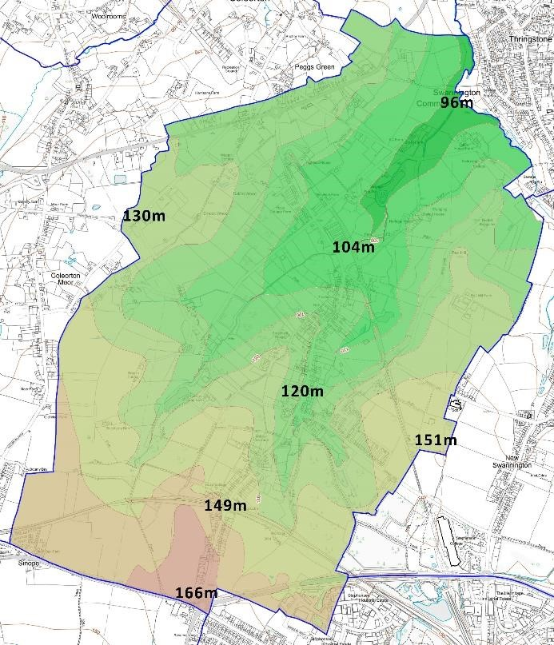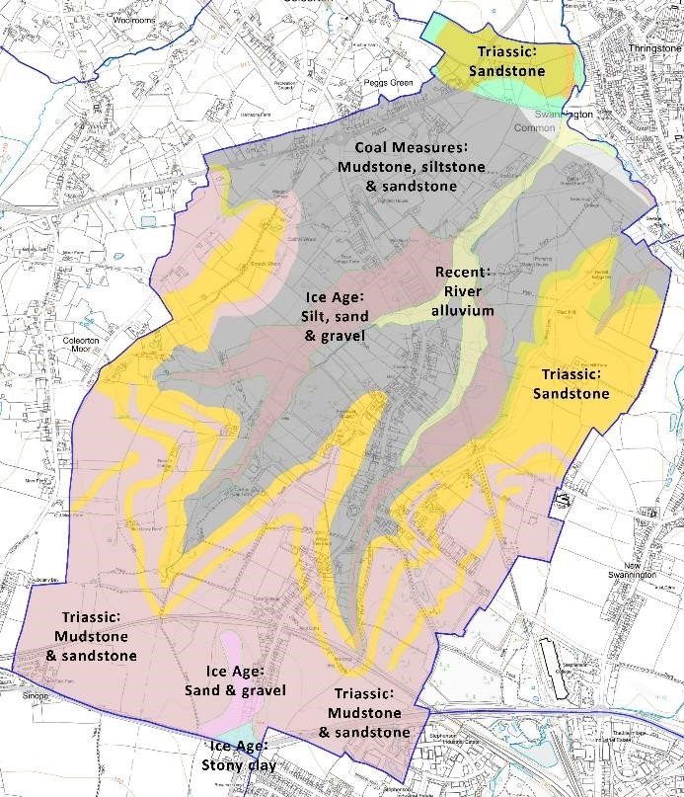
Historic environment

The presence of people in the Plan Area in prehistoric times is demonstrated by finds and cropmarks, while its Romano-British occupation is proven by settlement sites at Redhill farm, Station Road and Spring Hill and by the Roman road now followed by the course of the modern A511; although these sites are not recorded in the Leicestershire Historic Environment Record (HER) as locations with buried archaeology requiring site-specific attention in new development, the potential for significant prehistoric and Roman heritage under development sites throughout the Plan Area should not be forgotten. The present settlement of Swannington, whose linear layout was dictated over a thousand years ago by the valley topography of its location, was probably founded in the ninth century by a mixed group of people with both Anglo-Saxon and Viking heritage, as suggested by the place-name:

Swannington 'Farm/settlement connected with Swan':
Swan (cf. modern Svein) (old Norse) personal name -ing (Old English) … named after, or connected with … tūn (Old English) ‘settlement, farmstead’
Adapted from Key to English Place-names (KEPN), Nottingham University
The location of Swannington in the ‘old Leicestershire Coalfield’ still characterises its modern historic environment. Small-scale mining was probably part of the local economy almost from the foundation of the village. The Romans are known to have exploited surface coal seams locally, while the Swannington Heath area preserves earthworks evidence of coal workings, from medieval bellpits to 19th-century collieries, and the railway network associated with the latter. The small fields (miners’ smallholdings), the proliferation of footpaths and the absence of medieval open field ploughlands in this northern half of the area are features of an historical landscape that is the direct legacy of land use in the old coalfield. The southern half of the Plan Area only became part of the Leicestershire Coalfield in the late 19th century, when deep mining began to exploit seams at much greater depth; an expansion of the village dates from this time and another from the mid-20th century. The southern half was farmed in the conventional medieval way, with large, open arable fields whose ploughing strips survived under later pasture into the 20th century. The distinction between the two medieval landscapes (coalfield and farming) can still be seen today and is an important part of Leicestershire’s historical landscape.

Natural environment
Swannington’s topography and geology, its long and varied agricultural and industrial history, and its location within the National Forest area – itself partly a legacy of coal-mining – have resulted in the survival of a relatively (for the 21st century English Midlands) biodiverse Plan Area. Of particular significance are the several fields in the old coalfield area, recognised by Local Wildlife Site designations, where the grassland flora and fauna are reminiscent of the less agriculturally intensive management style of the early 20th century with its associated biodiversity benefits. National Forest plantings are also sites of developing biodiversity significance, while biodiversity elsewhere has been further improved by local community initiatives.

Existing environmental designations
The Plan Area is located in National Character Area (as defined by Natural England to guide Planning) 71 Leicestershire and South Derbyshire Coalfield, and the North West Leicestershire District Council Historic Settlements and Enclosures Landscape Area type. There are eight Listed Buildings, 12 non-listed buildings (non-designated heritage assets) in the Leicestershire CC Historic Environment Record (HER), and 44 further sites and features of historical significance, also in the Leics. HER.
There are no SSSIs in the Plan Area, but it is within the medium to low Impact Risk Zones (all more than 500m distant) of several ecological and geological SSSIs in nearby parishes. There are 16 areas of Priority Habitat (as defined by Natural England), 14 further sites (some 60 ha) in the national Forest Inventory, and over 40 Local Wildlife Sites (current and historic) recorded by Leicestershire CC.
Figure 5: Impact Risk Zones in the Plan Area of SSSIs in nearby parishes
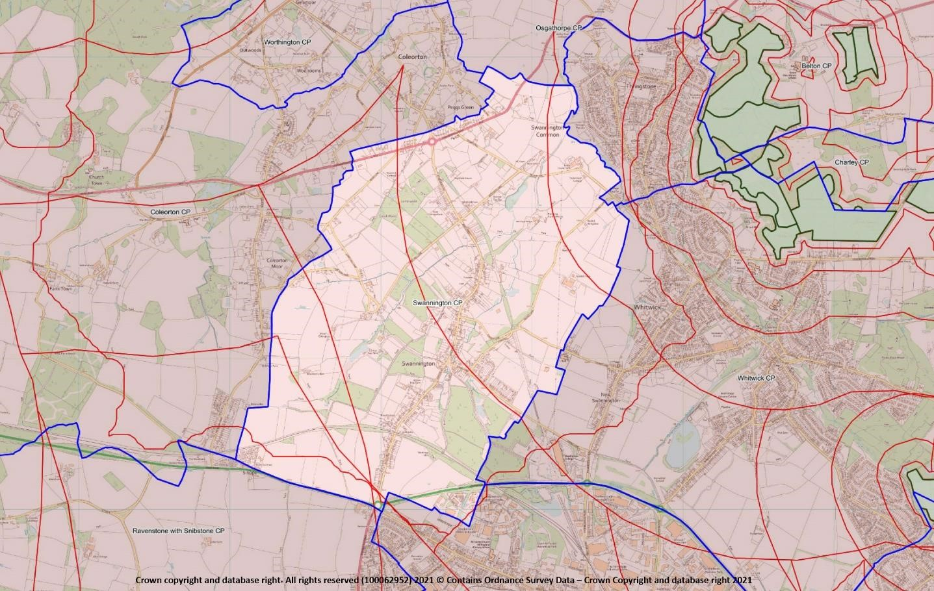

Environmental inventory

An environmental inventory of Swannington (Appendix F) was carried out between December 2019 and September 2020. The work comprised two elements:
- Review of all existing environmental designations and other available information in the public domain and
- Fieldwork to identify and confirm environmentally significant (in the context of the Plan Area) sites and features.
The review compiled information from many sources, including DEFRA, Natural England, Historic England, Leicestershire Historic Environment Records, Leicestershire Environmental Record Centre records (biodiversity and geology), North West Leicestershire, Environment Agency, British Geological Survey, old maps (Ordnance Survey, archive), local history and archaeology, publications and local knowledge.
Fieldwork reviewed all open and currently undeveloped land in the Plan Area. Significant species, habitats, public open spaces, landscape characteristics, earthworks and other extant heritage features, views and viewpoints were checked and recorded.
These data, along with all relevant site-specific information from the existing information review, were mapped and tabulated, and each site was scored and evaluated using the seven criteria for Local Green Space selection in the National Planning Policy Framework 2019.

Local Green Space
As noted above, the 266 surveyed parcels of open land in the parish were scored using the seven criteria for Local Green Space designation noted in the National Planning Policy Framework 2019 (see Appendix F for the criteria and scoring system devised for this Plan). Of the total, some 76 were identified as having notable environmental (natural, historical and/or cultural) features, and of these, two sites score 70% (17/25) or more of the maximum possible and meet the other essential requirements for designation as Local Green Space as outlined in the National Planning Policy Framework (NPPF 2019, paragraphs 99-101).
Their statutory protection will ensure that these most important places in Swannington’s natural and human environment are protected.
POLICY ENV 1: LOCAL GREEN SPACES – Development proposals that would result in the loss of, or have an adverse effect on, the following Local Green Spaces (details Appendix G; map figure 6) will not be supported other than in very special circumstances.
Main Street / Jeffcoats Lane recreation ground (inventory reference 302)
Gorse Field (218)
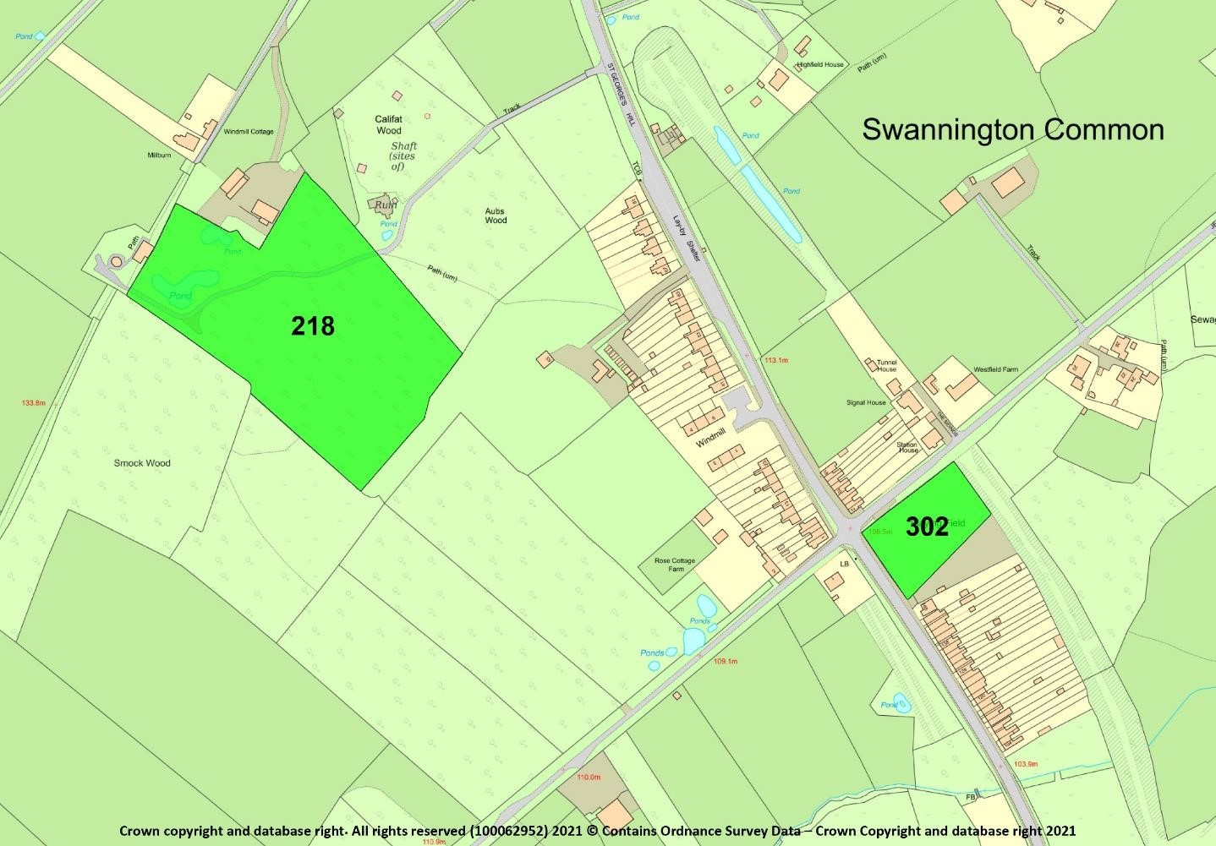
Figure
6
:
Local Green Spaces

Important Open Spaces
A group of sites scored highly in the inventory for their community value. They have been identified in fieldwork, community consultations and in Parish records. Their value as open space within and close to the built-up areas and/or their current, or potential, value as community resources are recognised in this Policy. Some are existing North West Leicestershire District Council Open Space, Sport & Recreation (OSSR) sites (as recorded in the North West Leicestershire District Council PPG17 Open Space, Sport and Recreation Audit 2008) and/or Swannington Parish Council assets. The remainder have demonstrable community value and can be classified in NWLDC OSSR typologies, and are included here for similar protection in the Planning system.
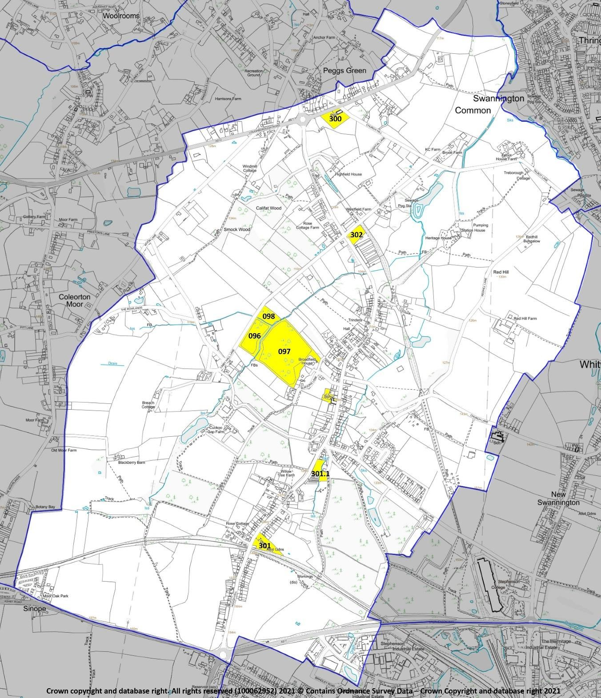
Figure
7
:
Important Open Spaces

POLICY ENV 2: IMPORTANT OPEN SPACES - The following open spaces (and figure 7) are of high value for recreation, beauty, amenity, tranquillity or as green spaces within or close to the built-up area. Development proposals that result in their loss, or have a significant adverse effect on them, will not be supported unless the open space is replaced by equivalent or better provision in an equally suitable location, or unless the open space is no longer required by the community.
Main Street / Jeffcoats Lane Playing Field (inventory reference 302; NWLDC OSSR audit Local Open Space)
Swannington School grounds, Main Street (no ref.; NWLDC OSSR audit Schools)
Swannington St George’s churchyard (300; this Plan Commons, allotments and cemeteries)
Upper allotments, Station Hill (301; this Plan Commons, allotments and cemeteries)
Lower allotments (village centre), Station Hill (301.1; this Plan Commons, allotments and cemeteries)
Walkers Wood (096-098, three parts; this Plan Informal countryside/nature conservation)

Natural environment and biodiversity

Sites of natural environment significance
A group of inventory sites scores highly for ‘wildlife’ (scoring at least 3/5 under this criterion). The features for which the identified sites have been selected and notified are listed in the environmental inventory (Appendix F). They comprise a) sites where priority habitats occur (Natural England mapping); b) Local Wildlife Sites designated by Leicestershire County Council in Phase I habitat surveys, and c) sites in the National Forest Inventory, mostly new woodland plantings with rapidly developing biodiversity value. The map (figure X) shows their locations.
Policy ENV 3 delivers site-level compliance in the Plan Area with the relevant North West
Leicestershire District Council policies, the Wildlife & Countryside Act 1981 (as amended), the Natural Environment and Rural Communities Act 2006, and the European Habitats and Species Directives, Transitional Legislation in the Withdrawal Act 2018 and the measures outlined in the Draft (Principles and Governance) Environment Bill 2019. It also acknowledges the ecological and environmental (for carbon sequestration, etc.) significance of the areas of semi-natural woodland in the Plan Area and the more extensive new plantings in the National Forest.
POLICY ENV 3: SITES AND FEATURES OF NATURAL ENVIRONMENT SIGNIFICANCE – The sites and features mapped here (figure 8) have been identified as being of at least local significance for their natural environment significance. They are ecologically important in their own right, make a local contribution to carbon sequestration, and are locally valued. The significance of the species, habitats or features present should be balanced against the local benefit of any development that would adversely affect them.

Figure 8: Sites of natural environment significance
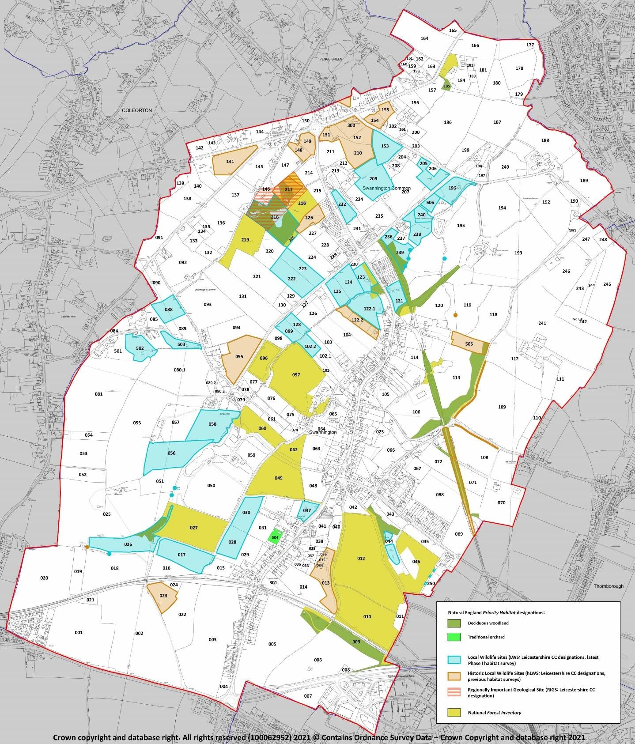

Protecting and enhancing biodiversity

It might be said that Swannington is an unexceptional area of English Midlands countryside because it has no nationally important wildlife hotspots. This would be a misunderstanding of the concept of biodiversity. England’s biodiversity is entirely and only the sum of the wildlife in all of its individual parishes: Swannington is as important in this regard as every other parish, particularly so in view of its Local Wildlife Sites and location in the National Forest, area. Residents want it to play its essential part in protecting what remains of England’s threatened and diminishing biodiversity.
This policy is therefore about parish-level compliance with the relevant North West Leicestershire District Council Local Plan policies, the Wildlife & Countryside Act 1981 (as amended), the Hedgerows Regulations 1997 (as amended), the European Habitats and Species Directives [or their transitioned English equivalents] and other relevant English regulations – and about how Swannington can play its part in maintaining and enhancing biodiversity by taking it into account, at a Neighbourhood Plan level of detail, in the Planning system. The policy is supported by National Planning Policy Framework (2019) paragraphs 170 (a) and (d); 174; 175 (a) on which this policy’s wording is partly based, 175(c); and 177. The community expects planning decisions affecting Swannington to follow the spirit of the Government’s 25 year environment plan (2018) and the Environment (Principles and Governance) Bill (2019).
POLICY ENV 4: PROTECTING AND ENHANCING BIODIVERSITY– All new development proposals will be expected to safeguard habitats and species, including those of local significance. If significant harm to biodiversity cannot be avoided (through relocating to an alternative site with less harmful impacts), adequately mitigated, or compensated for, planning permission should be refused, in conformity with paragraph 175 of the NPPF.

Historic environment

Sites of historic environment significance
A group of inventory sites scores highly for ‘history’ (scoring at least 3/5 under this criterion). The features for which the identified sites have been selected and notified are listed in the environmental inventory (Appendix F). The map (figure 9) shows their locations.
These historic environment sites comprise a) sites with extant and visible archaeological or historical features or proven buried archaeology, as recorded in the Historic England Heritage Gateway and Leicestershire Historic Environment Records databases, and b) other sites of historical and social significance identified in local records and during the inventory process.
POLICY ENV 5: SITES AND FEATURES OF HISTORIC ENVIRONMENT SIGNIFICANCE - The sites mapped in figure 9 have been identified as being of at least local significance for their historical features. The features are extant and have visible expression, or there is proven buried archaeology on the site, and they are locally valued. The significance of the features present should be balanced against the local benefit of any development that would affect or damage them.
Development proposals should take account of known surface and sub-surface historical and archaeological features, and should ensure that, in consultation with the Leicestershire Historic Environment team, unknown and potentially significant deposits are identified and appropriately considered during development. Lack of current evidence of sub-surface archaeology must not be taken as proof of absence.

Figure 9: Sites and features of historic environment significance
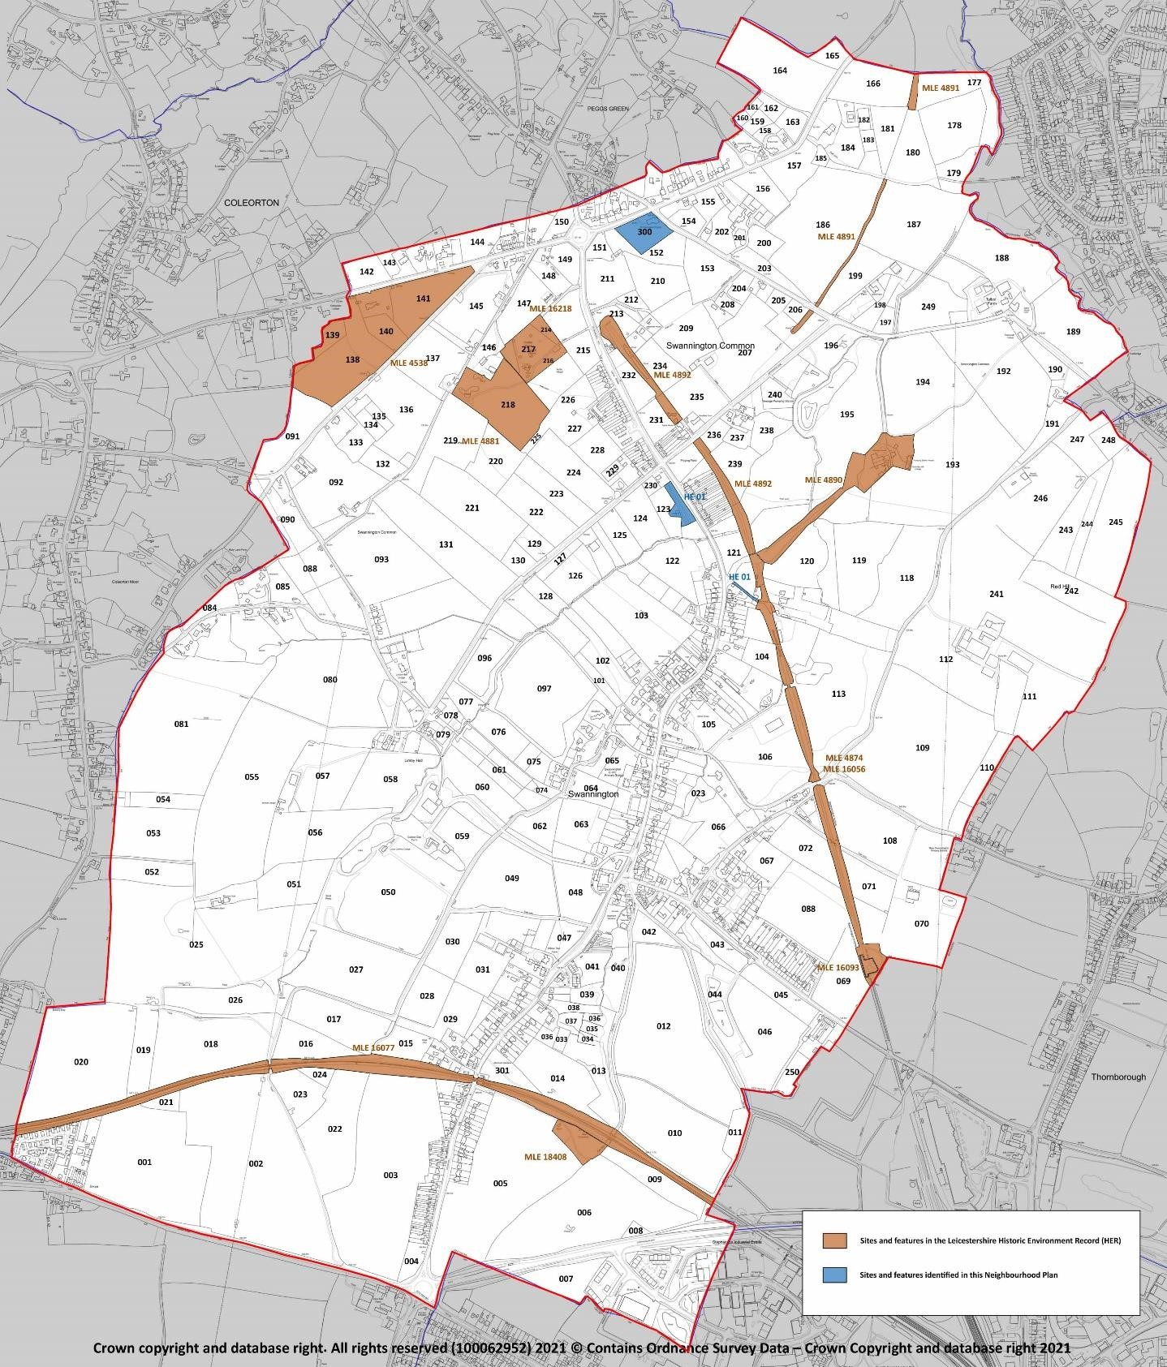

Statutorily protected heritage assets
Eight buildings and structures in the Plan Area have statutory protection through Listing at Grade II. The Neighbourhood Plan lists them (Appendix H) for reference, and to note that new development will be required to take them, and their settings as defined on a case-by-case basis by Historic England, into account.

Figure 10: Statutorily protected heritage assets (Listed Buildings)
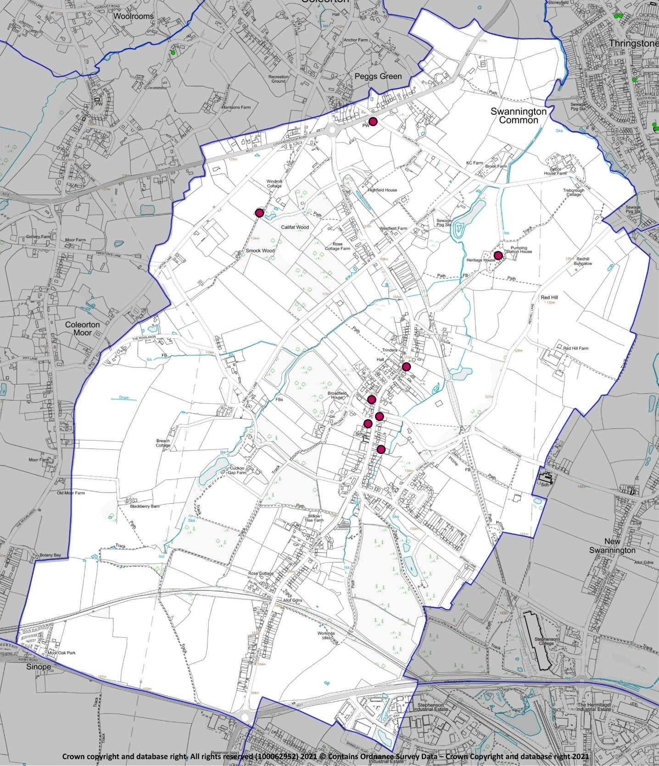

Local heritage assets
Leicestershire County Council has recognised 11 buildings and structures of at least local significance for architectural, historical or social reasons in the Leicestershire Historic Environment Record (HER). Their inclusion here records them in the Planning system as non-designated heritage assets. Inclusion in the Plan records them in order that they can be afforded protection at the appropriate level, as described in footnote (63) to NPPF 2019 paragraph 194.
POLICY ENV 6: LOCAL HERITAGE ASSETS – The structures and buildings listed here (and figure 11) are non-designated local heritage assets. They are important for their contribution to the layout and characteristic mix of architectural styles in the village, and their features and settings will be protected wherever possible. The local benefits of a development proposal, or of a change of land use requiring planning approval, will need to be judged against their significance as heritage assets.

MLE16771 Former Primitive Methodist Chapel, 2 Main Street
MLE23372 19th century school and school house, Main Street
MLE24649 The Station Inn, 6 Hough Hill
MLE24650 Nos. 12-16 Hough Hill
MLE24652 Nos. 64-70 Station Hill
MLE24653 Nos. 15-41 Station Hill

MLE24654 Elm Farm, 2 Main Street
MLE24655 Robin Hood Public House, Spring
Lane
MLE24656 Manor Farm, Main Street
MLE24657 Former Bull’s Head Inn, 71 Main Street
MLE24658 Nos. 2-18 St George’s Hill

Figure 11: Local Heritage Assets
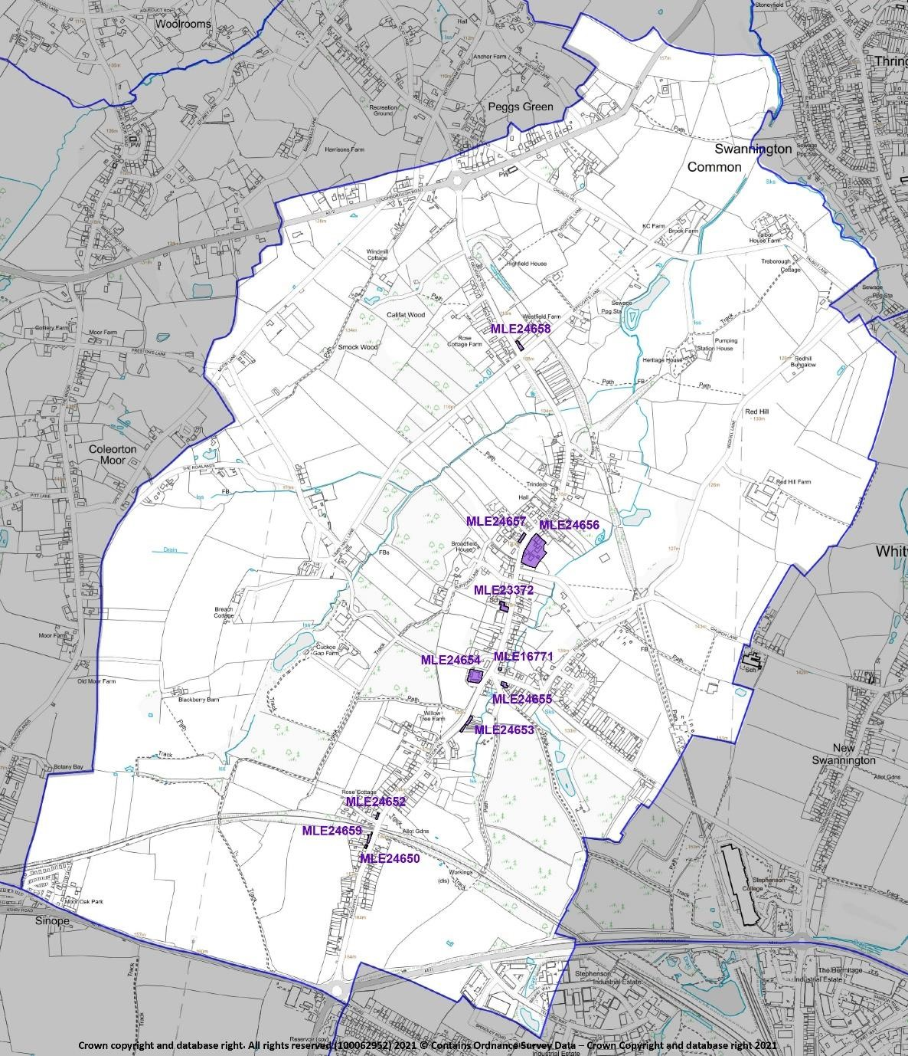

Important views
Consultation during the Neighbourhood Plan’s preparation identified a widely held wish to protect Swannington’s rural setting, in particular its visual relationship with the surrounding landscape.
One of the main ways in which residents expressed this wish was by describing several highly valued views within and around the village and toward the surrounding countryside. These consultation findings were supported by the environmental inventory, which although principally aimed at identifying sites of environmental significance also confirmed the sightlines of the suggested views and mapped them (figure 12).
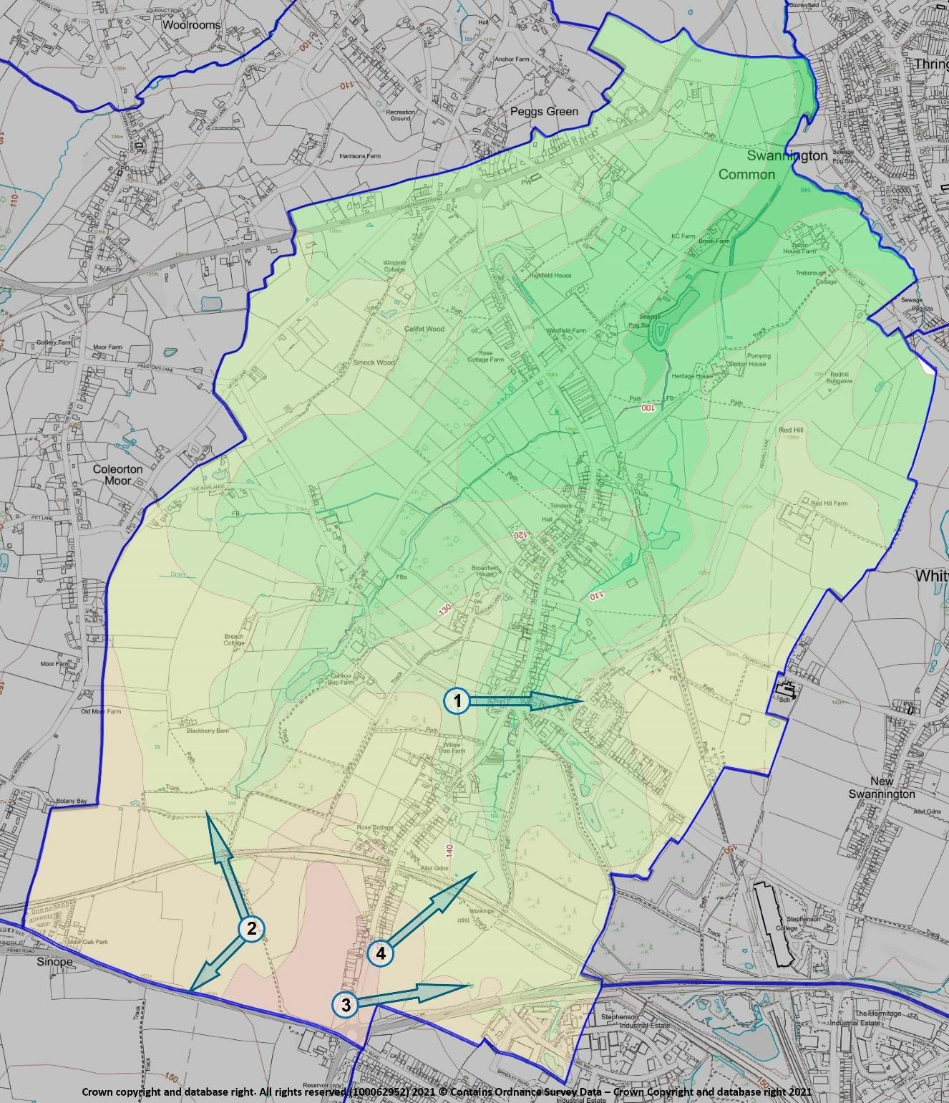
Figure 1
2
:
Important views

POLICY ENV 7: IMPORTANT VIEWS – The following views (and figure 12; details in Appendix I) are important to the setting and character of the village within the Plan Area. Development proposals should whenever possible respect and protect them. Development which would have an unacceptable impact on the identified views will not be supported.
- From field 048 (inventory reference) on the track forming the east side of an area of woodland, east over the village to the wooded hills on the far parish boundary
- From the high points in field 002 on footpath N25, extensive view northwest across the head of the valley in which Swannington is situated towards the high ground in the direction of Coleorton Moor, and southwest to the Plan Area boundary.
- From Hough Hill at the entrance to Swannington (field 004), east-northeast across the high ground in the south of the Plan Area
- From field 005 at the back of the Hough Hill area of the village, extensive views northeast over the eastern half of the Plan Area including the route of the Leicester & Swannington railway and the site of Calcutta mine and pumping engine

Footpaths, bridleways and byways
Figure 15 shows the extent of the existing network of footpaths, bridleways, byways and longdistance routes in the Swannington Plan Area. The wide distribution and coverage of these rights of way is a fortunate accident of history: they originated as natural, everyday, functional tracks for people, carts and pack animals during the centuries when Swannington was a busy coalfield with numerous small mines, their associated industries and crafts and the smallholdings to support the community. In most Midlands parishes, such natural landscape networks were tidied up in the agricultural and social ‘revolutions’ of the 18th and 19th centuries, but here in the old Leicestershire Coalfield they survived. Now, with community appreciation of the health benefits of walking and a growing awareness of the need to reduce carbon emissions, this survival can be seen as providing ready-made ways for direct, local, off-road travel, for example between the several outlying settlements and the main village’s facilities and for children to get to school in safety.
The existing footpaths network is consequently of very high present-day value, and determined efforts should be made to protect it in full, and whenever possible to ensure its maintenance and enhancement. Footpaths, bridleways and other similar rights of way are a County (Leicestershire CC) responsibility and, for development and maintenance, are outside the scope of the Neighbourhood Plan. Policy ENV 9 therefore reiterates good planning practice to deal a far as possible with threats to the network from new development.
POLICY ENV 8: FOOTPATHS, BRIDLEWAYS AND BYWAYS - Development proposals that result in the loss of, or have a significant adverse effect on, the existing network of footpaths, bridleways and byways (see Figure 13) will not be supported without appropriate mitigation.

Figure 13: Footpaths and bridleways
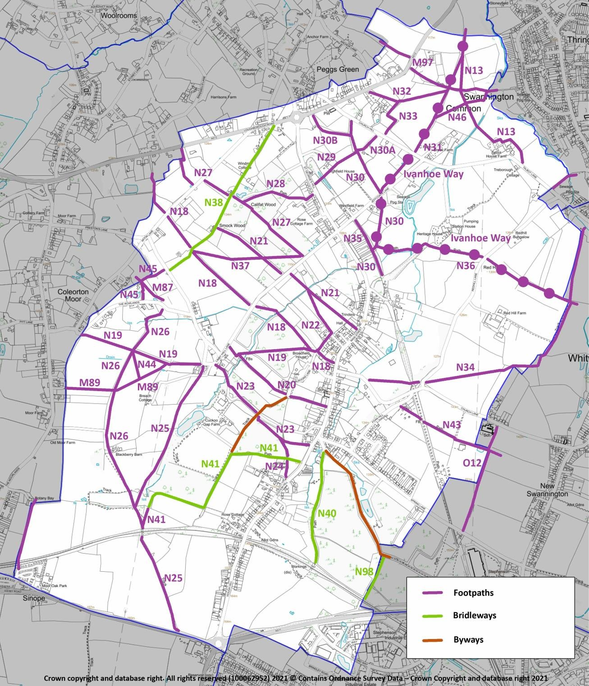

Flood risk resilience and climate change
Even if international cooperation and national strategies and policies eventually succeed in halting the human and industrial contributions towards climate change, the effects of recent and current warming on weather events will likely persist for decades. It is therefore desirable to plan for at least a medium-term future, in which weather events will continue to become more extreme, by putting in place measures that mitigate the challenge of climate change for the lifetime of this Plan and beyond. This objective is explicitly supported by the Environment Agency (EA) draft National Flood and Coastal Erosion Risk Management Strategy for England (2019), in which the strategic emphasis for the EA shifts from mitigation to resilience; in other words a switch from a requirement for new development to reduce its adverse effects on flood risk to the avoidance of creating or adding to flood risk at all.
A combination of topography and geology (see figure 6) restricts the areas susceptible to flooding (from fluvial or pluvial sources) to well-defined parts of the Plan Area. However, these almost all coincide with the likely locations of developable sites (in line with Local Plan and Swannington Neighbourhood Plan policies.
Local experience in recent years, including during the time of preparation of this Neighbourhood Plan (2019-2020), is that these types of flooding, particularly from surface water (pluvial flooding) have increased in extent, duration and severity. In light of this, it is particularly important that the location and technical standards of all new development proposals in the Plan Area should in future be judged on their likely contribution to flooding in a climate change world. To complement this, the community will support proposals to improve the infrastructure within the built-up areas for managing flooding from the rivers and from surface water run-off events, providing this is not unduly detrimental to the historic built environment, biodiversity sites, or open and green spaces.
This policy supports and is in conformity with NPPF paragraphs 155, 156 and 157, especially (b), and is strongly supported by the 2019 draft National Flood and Coastal Erosion Risk Management Strategy for England, particularly the strategy’s recognition of the need to build flood resilience into future strategic development planning. It is also in general conformity with North West Leicestershire District Council Local Plan policies Cc2 and Cc3.
POLICY ENV 9: FLOOD RISK RESILIENCE AND CLIMATE CHANGE – Development proposals within the areas shaded blue in figure 14 will be required, where appropriate, to demonstrate that the benefit of development outweighs the harm in relation to its adverse impact on climate change targets, and on the likelihood of it conflicting with locally applicable flood mitigation strategies and infrastructure.
Proposals to construct new (or modify existing) floodwater management infrastructure (ditches, roadside gullies, retention pools, etc.), including within the built-up area, will be strongly supported.
Development proposals of one or more dwellings and/or for employment development should demonstrate that:
- if in a location susceptible to flooding from rivers or surface water, no alternative site to meet the local residential development need is available;
- its location and design respect the geology, flood risk and natural drainage characteristics of the immediate area and is accompanied by a hydrological study whose findings must be complied with in respect of design, groundworks and construction;
- it includes a Surface Water Drainage Strategy which demonstrates that the proposed drainage scheme, and site layout and design, will prevent properties from flooding from surface water, including allowing for climate change effects, and that flood risk elsewhere will not be exacerbated by increased levels of surface water runoff and will not threaten other natural habitats and water systems;
- its design includes, as appropriate, sustainable drainage systems (SuDS) with ongoing maintenance provision, other surface water management measures and permeable surfaces;
- it does not increase the risk of flooding to third parties;
- proposed SuDs infrastructure includes, where practicable, habitat creation comprising e.g.
landscaping, access and egress for aquatic and terrestrial animals, and native species planting; and including a management plan for these measures, and
- it takes the effects of climate change into account.
Figure 14: Areas susceptible to flooding from surface water and watercourses
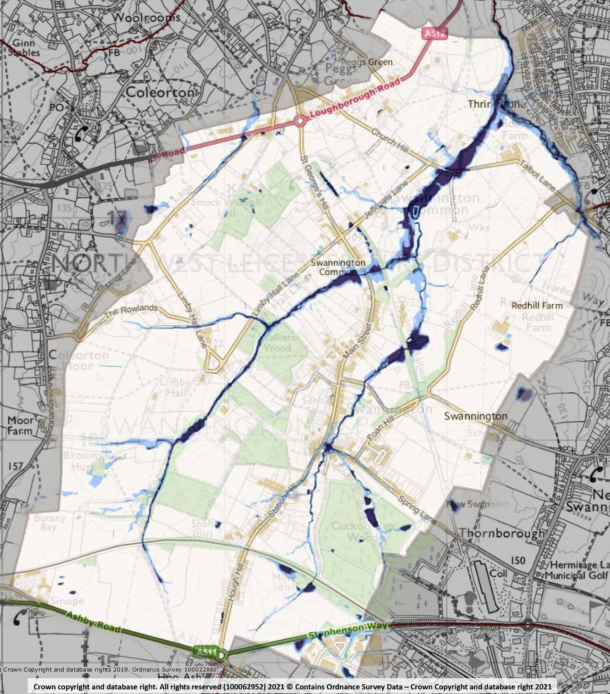
Compiled from
Environment Agency mapping

Renewable energy generation infrastructure
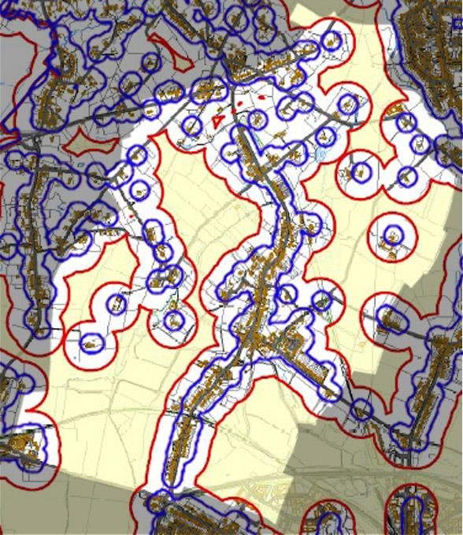
National Planning Policy Framework 2019 paragraphs 152-154 make it clear that all communities are responsible for reducing emissions as part of the necessary approach to mitigating and adapting to climate change. Residents of Swannington wish to play their part, but at a scale appropriate to the sensitive landscape of the Plan Area.
Figure
15:

Indicative map of areas unsuitable for large
and medium (within red line) and small (blue line) wind
turbines in the Plan Area. See text.

Adapted from relevant area of NWLDC Local Plan
S
upporting
D
ocument LP04

Turbines The impact of wind generation projects on communities has been recognised by the government: a Ministerial statement made on the 18th June 2015, notes that suitable areas for wind energy development must be identified in local plans (as has been done incompletely – see below – in NWLDC Local Plan 2017 policy Cc1, supporting documents LP-04-1-3 and as described generally in paragraphs 12.5 to 12.14) and that any such developments must have the support of local communities. Paragraph 12.12 of the Local Plan states that potentially suitable areas for large and small turbine proposals (and thus by implication those unsuitable for it) “will require detailed assessment during the planning process … and on a site-bysite basis”.
Figure 15 combines the Plan Area sections of the indicative NWLDC Local Plan maps of areas unsuitable for turbines (supporting documents for Local Plan Policy Cc1 and the LP policies map). The originals were evidently generated by plotting circles of radii 55m and 143m around residential buildings, but they take no account of topography, landscape sensitivity or existing environmental designations. Furthermore, the Landscape Sensitivity Study (Leicester and Leicestershire LSA and GI Study Report, 2017) referred to in Local Plan paragraphs 12.5-12.12 does not specifically quantify sensitivity to turbines (the Plan Area as a whole is classed as of medium sensitivity to residential and commercial development). The Plan Area is in national Character Area 71 Leicestershire and South Derbyshire Coalfield, in which there is no reference to turbines but where it is stated that the ‘open landscape’ requires mitigation of a range of development types to ‘avoid visual impact on the landscape and [ensuring that] levels of noise and light pollution are minimised to preserve areas of tranquillity’.
To provide both clarity for speculative developers and a statement of the conditions under which the local community would support renewable energy infrastructure developments, this Neighbourhood Plan provides a strategic basis for making such assessments in the Swannington Plan Area.
POLICY ENV 10: RENEWABLE ENERGY GENERATION INFRASTRUCTURE – Proposals for single smallscale (turbines less than 30m), local resident, business, amenity or community-initiated, solar and wind generation infrastructure will be supported, subject to their being outside the areas enclosed by the red line on figure xx and complying with the environmental protection conditions listed in NWLDC Local Plan (2017) Policy Cc1.
Large and medium scale (one of more, larger than 30m) turbine developments will not be supported, in general conformity with NWLDC Local Plan Policy Cc1 and Ministerial Statement HCWS42 of 18-6-2015.

6. Community sustainability

Community facilities

Existing facilities
Community facilities and amenities provide important infrastructure for the residents of Swannington, supporting and enhancing the quality of daily life and contributing to the vitality of the village.
Some of these facilities and amenities offer local employment opportunities whilst others provide a focal point for social interaction and support important services; thereby reducing the need to travel, which is particularly important for those who do not have access to a car.
The loss and threatened closure of facilities and services is, however, a common dilemma for rural communities. The viability of many rural services is likely to be challenged further in future as a consequence of squeezed local authority budgets and more car owning residents commuting to work, driving to retail centres and accessing leisure facilities and other amenities further afield.
Swannington village has a reasonably good range of facilities which include:
- 2 Public Houses, both of which provide meals, but neither provide accommodation;
- The Village Institute, which is owned and operated by the Parish Council. It is currently used on a regular basis by various organisations, and which can be hired, subject to availability, for private functions;
- The Church which is located at the north of the village. There are no other religious establishments within the village;
- 2 groups of allotments for rent within the village which are managed by the Parish Council;
- A small recreation ground with play facilities;
- An Indian restaurant, which is extremely popular in the area and which provides take away facilities;
- B & B establishment.
- A formal designated cycle track, running from the village centre to the A511/Stephenson’s College in Coalville:
- Swannington Incline
- Site of Snibston 3 Colliery on Spring Lane
- Hough Windmill

POLICY CF1: THE RETENTION OF COMMUNITY FACILITIES AND AMENITIES - Development leading to the loss of an existing community facility (including …) will not be supported unless it can be demonstrated that any of the following apply:
  - There is no longer any proven need or demand for the existing community facility;
  - The existing community facility is no longer economically viable and there are no alternative uses for the building that meet a community need;
  - The proposal makes alternative provision for the relocation of the existing community facility to an equally or more appropriate and accessible location within the Parish which complies with the other general policies of the Neighbourhood Plan.

New facilities
Community consultation confirmed the importance of enhancing the range and quality of community facilities and amenities in the parish, recognising their value to the local community.
In the Questionnaire results, the community identified the following facilities as being lacking locally: a Post Office, shop(s) for general provisions, youth initiatives, sports fields, more visits by a mobile library, picnic/seating areas, rail links and a doctors surgery.
Residents also identified the need for open space for people to meet socially/village fete etc. and better public car parking facilities.
POLICY CF2: NEW OR IMPROVED COMMUNITY FACILITIES - Proposals that provide new community facilities (such as a new village hall, medical facility or shop) or improve the quality and range of existing community facilities, will be supported provided that the development:
- Meets the design criteria stated in Policy H6;
- Will not result in unacceptable traffic movements that generate increased levels of noise, fumes, smell or other harmful disturbance to residential properties including the need for additional parking which cannot be catered for within the curtilage of the property;
- Will not generate a need for parking that cannot be adequately catered for within the development;
- Is of a scale appropriate to the needs of the locality and conveniently accessible for residents of the village wishing to walk or cycle;
- Takes into full account the needs of the disabled.

School
Swannington CE Primary School is a small village school for children aged between 4 and 11. It offers small class sizes in a distinctly Christian environment and is one of five schools that are part of the Oval Learning Trust in North West Leicestershire. It is proud to be a Church of England School, sitting at the very heart of the village community in Swannington.
POLICY CF3: PRIMARY SCHOOL - Proposals for the expansion of the existing primary school in the village will be actively supported where it can be demonstrated that:
- The expansion would not exacerbate existing access related or traffic circulation problems, unless suitable mitigation measures are brought forward as part of the proposal;
- There is no significant loss of outdoor recreation space at the school;
- The development would not result in a significant loss of amenity to local residents or other adjacent users and is in character, scale and form to the current building.

Where expansion is not possible on the current site, the creation of a new school in the village will be supported where:
- It would be safely accessible by pedestrians and cyclists and is well related to bus routes
- It has appropriate vehicular access and does not adversely impact upon traffic circulation;
- It would not result in a significant loss of open space and amenity to local residents or other adjacent uses:
- Off-road parking would be provided for staff and visitors.

Employment

Existing
The strength of the local economy and of the community go hand in hand. Supporting the growth of a stronger local economy is recognised as an important theme of the Neighbourhood Plan. Indeed, the North West Leicestershire District local plan for 2011-2031 recognizes the need for sustainable development which both delivers local employment opportunities, supports and diversifies the rural economy and enables the expansion of local enterprise. Swannington is a rural parish with a traditional agricultural and industrial heritage and is relatively distant from the major employment centres. Employment opportunities within the parish are therefore limited in scale.
There are also established businesses which are run from home-based facilities within the village.
There is an increasing trend for residents to work from home (5% of people living in the parish (aged 16-74) compared to 3.6% in North West Leicestershire District) and with continuing changing employment patterns nationally, this trend is likely to continue.
For the majority of workers resident in the parish the lack of significant local employment opportunity means that their only option is to work away from the area, commuting increasingly greater distances to secure employment. In view of the rural nature of the village, 55% of residents go to work by car, above the rates for the North West Leicestershire district (53.9%) and England (40.2%). The lack of both local employment and affordable housing impacts particularly on the young people of Swannington.
Where there are buildings dedicated to business use in the parish it is important that they are protected against being lost to other uses. It should be clearly demonstrated that there is little prospect of existing building or land generating employment before allowing demolition or redevelopment.
When asked in the Community Questionnaire in 2019 if people supported more small businesses into the village, 31% of respondents thought that employment in Swannington was extremely important and 40% it to be of some importance.
POLICY E1: SUPPORT FOR EXISTING EMPLOYMENT OPPORTUNITIES - Where planning permission is required there will be a strong presumption against the loss of existing commercial premises or land (B-class) which provides employment or future potential employment opportunities. Applications for a change of use for an activity that does not provide employment opportunities will only be permitted if it can be demonstrated that:
- The commercial premises or land in question has not been in active use for at least 12 months;
- The commercial premises or land in question has no potential for either reoccupation or redevelopment for employment-generating uses and as demonstrated through the results both of a full valuation report and a marketing campaign lasting for a continuous period of at least six months.

New employment opportunities
New employment initiatives in the right location can greatly help to boost and diversify the local economy and to provide more local employment opportunities.
Overall, maintaining the rural nature of the parish strongly mitigates against any larger scale business development, although the existing business park located outside of the village does provide some scope for expansion within its boundary.
Any new employment initiatives should be sensitive to the character of the parish. Employment proposals should only be seen as acceptable if they avoid harmful impacts on other matters agreed to be locally important such as air quality, green spaces, increased traffic flows, parking, residential amenity, the preservation of historic/heritage assets and the local environment.
There is, however, a need to recognise and support the increasing numbers of people who conduct their businesses from home. The Neighbourhood Plan reflects this in its proposals to provide a wider range of housing and to both support conversion of redundant commercial buildings and the development of local business premises where appropriate.
POLICY E2: SUPPORT FOR NEW EMPLOYMENT OPPORTUNITIES - In supporting additional employment opportunities, new development should:
- Fall within the boundary of planned limits of development unless it relates to small scale leisure or tourism activities, or other forms of commercial/employment-related development appropriate to a countryside location or there are exceptional circumstances;
- Where possible, be sited in existing buildings or on areas of previously developed land;
- Be of a size and scale not adversely affecting the character, infrastructure and environment of the village itself and the neighbourhood plan area, including the countryside;
- Not involve the loss of residential dwellings;
- Not increase noise levels or light pollution or introduce any pollution to an extent that they would unacceptably disturb occupants of nearby residential property;
- Not result in unacceptable levels of traffic movements that generate increased levels of noise, fumes, smell or other harmful disturbance to residential properties including the need for additional parking which cannot be catered for within the curtilage of the property;
- Contribute to the character and vitality of the local area;
- Be well integrated into and complement existing businesses.

Working from home
The reduction of CO2 omissions to net zero by 2050 is now enshrined in law, so it is important to consider new employment opportunities in the right location for the residents of Swannington in order to help reduce vehicle usage and carbon footprint. The last census of 2011 identified 13.1% residents as self-employed and 5% working mainly from home. 549 people regularly drove to work and back making a total of over 1,000 vehicle journeys per day.
It has been demonstrated that there is support for those people who wish to conduct their business from within the village. Again through the consultation process this will only be seen as acceptable if it avoids impact on other matters that are considered equally important, such as increased traffic flows, parking, retaining the residential amenities, the local environment and the preservation of historic and heritage assets. As stated earlier, 31% of respondents thought that employment in Swannington was extremely important and 40% it to be of some importance. The neighbourhood plan therefore supports the rural economy by allowing for new employment planning applications to provide or safeguard local jobs.
POLICY E3: WORKING FROM HOME - Proposals for the use of part of a dwelling for office and/or light industrial uses, and for small-scale free-standing buildings within its curtilage, extensions to the dwelling or conversion of outbuildings for those uses, will be supported where:
- Such development will not result in unacceptable traffic movements and that adequate onsite parking provision is available for employees and visitors;
- No significant and adverse impact arises to nearby residents or other sensitive land uses from noise, fumes, light pollution, or other nuisance associated with the work activity;
- Any extension or free standing building shall be designed having regard to policies in this Plan and should not detract from the quality and character of the building to which they are subservient by reason of height, scale, massing, location or the facing materials used in their construction.

Farm diversification
The conversion of former agricultural buildings enables farm diversification, leads to the sustainable reuse of vacant buildings and provides opportunities for the establishment and development of small businesses which generate income and employment opportunities for local people. This is a national trend, which the Parish Council would like to encourage within the Plan area to maintain a balanced and vibrant community, subject to the proper consideration of residential amenity for nearby houses, visual impact on the countryside and highway safety issues. New business development in the countryside is covered in Policy E2.
To help maintain the rural economy and protect the open countryside from inappropriate development, the Plan supports the sustainable growth and expansion of business and enterprise through the development and where appropriate conversion of farm existing buildings in the countryside. Specifically, this is intended to: Promote a viable and sustainable farming and rural economy in the Neighbourhood Area and the diversification of rural businesses; encourage new businesses to provide a wider range of local produce, services and leisure facilities, to provide local employment and attract both visitors and tourists to the parish and maintain and enhance the local environment of rural and agricultural lands.
The change of use of some rural buildings to new uses is already permitted under the General Permitted Development Orders. The Town and Country Planning (General Permitted Development) (Amendment and Consequential Provisions) (England) Order 2014 allows, under certain circumstances, the change of use of agricultural buildings to residential use and change of use of agricultural buildings to registered nurseries providing childcare or state-funded schools, under the prior approval system.
POLICY E4: REUSE OF AGRICULTURAL AND COMMERCIAL BUILDINGS - The reuse, conversion and adaptation of rural buildings for small businesses, recreation, or tourism purposes will be supported where:
- The use proposed is appropriate to the rural location;
- The conversion/adaptation works respect the local character of the surrounding area;
- The development will not have an adverse impact on any archaeological, architectural, historic or environmental features;
- The local road system is capable of accommodating the traffic generated by the proposed new use and adequate parking can be accommodated within the site;
- There is no significant adverse impact on neighbours through noise, light or other pollution, increased traffic levels or increased flood risk.

Tourism
Swannington is attractive as a destination for rural leisure activities which include cycling and walking as well as less strenuous pastimes and just relaxing in pleasant surroundings. Swannington supports an Air B&B that provides accommodation.
Leicestershire’s tourism strategy recognises the importance of tourism in providing ‘sustained and sustainable growth and playing an increasingly significant role in the success of the economy, creating a strong sense of place and improved quality of life for Leicestershire people’. (tourism strategy for Leicestershire, 2016). This is also in accordance with Section 3 of the NPPF which encourages planning policies that support sustainable rural tourism.
POLICY E5: TOURISM - Support will be given to facilities that enhance and promote tourism where:
- They are within or adjoining Swannington on a scale appropriate to the nature of the village;
- They do not have a detrimental effect on the distinctive rural character of the Parish;
- They do not adversely affect the surrounding infrastructure, particularly local road networks, water supply and sewerage;
- They benefit the local community through, for instance, provision of local employment opportunities and improvements to local service provision appropriate in scale to their location;
- They involve the reuse of existing buildings subject to policy E4, or;
- They form part of farm diversification.

Broadband
The North West Leicestershire District Local Plan only allows development where there is adequate broadband infrastructure in place. This neighbourhood plan recognises the fundamental importance of ultra-fast broadband to the development of the local economy and that rural communities must not be disadvantaged with a poor communication infrastructure. Such facilities are particularly important for promoting and developing homeworking as outlined in policy E3.
In the Community Questionnaire a question was asked about broadband speed and service. 68% thought that this was extremely important, and 29% thought it of some importance.
POLICY E6: BROADBAND INFRASTRUCTURE - Proposals to provide increased access to a super-fast or ultra-fast broadband service (including future developments at present unforeseen) and improve the mobile telecommunication network that will serve businesses and other properties within the parish will be actively supported. This may require above ground network installations, which must be sympathetically located and designed to integrate into the landscape and not be located in or near to open landscapes.
- All new developments should have access to superfast broadband (of at least 30Mbps). Developers should take active steps to incorporate superfast broadband at the pre-planning phase and should engage with telecoms providers to ensure superfast broadband is available as soon as soon as the initial build on the development is complete; and
- Telecommunication providers will be encouraged to improve existing mobile coverage and provide new 5G services.

Traffic
From the results of the Community Questionnaire, concerns were expressed about speeds, onstreet parking and congestion in the vicinity of the school at arrival and dispersal times. 81% of respondents were extremely concerned about speeding and 67% were extremely concerned about “School run parking”.
It was noted by the St Georges Hill Vehicle Activated sign that there was some 58,000 activity recordings in a 3 week period indicating the volume of traffic in the village
POLICY T1: TRAFFIC MANAGEMENT - With particular regard to the rural highway network of the Parish and the need to minimise any increase in vehicular traffic all development must:
- Be designed to minimise additional traffic generation and movement;
- Incorporate sufficient off-road parking in line with policy H?;
- Provide any necessary improvements to site access and the highway network either directly or by sufficient financial contributions;
- Consider, where appropriate, the improvement and where possible the creation of footpaths and cycleways to key village services; and
- Enhance pedestrian facilities and to provide formal pedestrian crossings where appropriate.

Swannington does not have any public car parking areas other than an area opposite Station Inn on Hough Hill and the residents are rightly concerned about increases in street parking, which has unfortunately become essential for houses which either have no garages or off-street parking availability. This is causing an impact on the wide variety of vehicles that need to travel through the village including essential utility services and agricultural machinery. Where possible residents should be encouraged to use their garages and existing driveways to park their cars to reduce this problem. Any proposed new developments should include adequate off-street parking arrangements and garages to mitigate this issue.
POLICY T2: CAR PARKING - Development proposals that would result in the loss of off-street car parking on the areas shown on the Proposals Map would only be acceptable where:
- It can be clearly demonstrated that there is no longer any potential for the continued use of the land for car parking and that the loss of parking will not aggravate an existing shortfall of spaces in the vicinity.
- Adequate and convenient replacement car parking spaces will be provided elsewhere in the vicinity.

The Neighbourhood Plan will support proposals to establish a new public car park or extension of an existing public car park in the village at a suitable location.

Electric car charging
The UK government has recently announced its intention to ban sales of new petrol and diesel cars from 2040 to combat rising levels of air pollution (in particular NOx) and address climate change concerns. The implication is that the number of ‘pure’ (i.e. not hybrid) electric vehicles (EVs) on the road will increase rapidly; there is some evidence this is already starting. If EVs are to have a similar range to today’s petrol/diesel cars, they will need to have large capacity batteries installed (for example, an EV with a 310-mile (500kms) range requires a battery capacity of 90kWh). This raises the crucial question for the planning system of providing infrastructure for EV battery recharging.
Residential charging is probably the current norm but using a typical generator size of 3.7kW (as currently installed as standard on board EVs, with similar electrical usage as a domestic kettle), this would take 19 hours to re-charge the battery (assuming a typical run-down state of 25% of maximum). The lower capacity (and lower range <100miles) Nissan Leaf would take about 6 hours. The availability of larger capacity on-board generators (7kW) is emerging, which would halve these times, but this is then the maximum that would be possible using current standard domestic electricity supply (single phase 240volt). However, residential charging is only allowed where offroad parking is available.
This issue is already influencing planning and building regulations and it would seem wise to include such requirements for new developments in Swannington, if rural communities are not to be left behind. Similarly, commercial rapid charging facilities are growing across the country (making use of 3-phase supply not possible at the domestic level and reducing the 7kW re-charge time by a factor of 3). These could be utilised in Swannington for example by installation in a permanent parking area as described above, providing re-charging for residents with no off-road parking, and allowing opportunity fast re-charge for all residents.
POLICY T4: ELECTRIC VEHICLES - Residential development should, where practical, provide 7kW (or current best practice) cabling to a vehicle-accessible location on the exterior of each dwelling to facilitate subsequent installation of a home electric vehicle charging point.
The provision of communal vehicular charging points within the Parish will be supported where there is universal access and their presence does not impact negatively on existing available parking in the Parish.

7. Monitoring and Review
The Neighbourhood Plan will last up to 2031. During this time, it is likely that the circumstances which the Plan seeks to address will change.
The Neighbourhood Plan will be monitored regularly. This will be led by Swannington Parish Council on at least an annual basis. The policies and measures contained in the Neighbourhood Plan will form the core of the monitoring activity, but other data collected and reported at the Parish level relevant to the delivery of the Neighbourhood Plan will also be included.
The Parish Council proposes to formally review the Neighbourhood Plan on a five-year cycle commencing in 2026 or to coincide with the review of the North West Leicestershire Local Plan if this cycle is different, or when significant changes occur in national planning policy that impacts on Swannington.

