**Valley Beat**

**Newsletter**



**Issue: February 2024**

**Your Local Team**

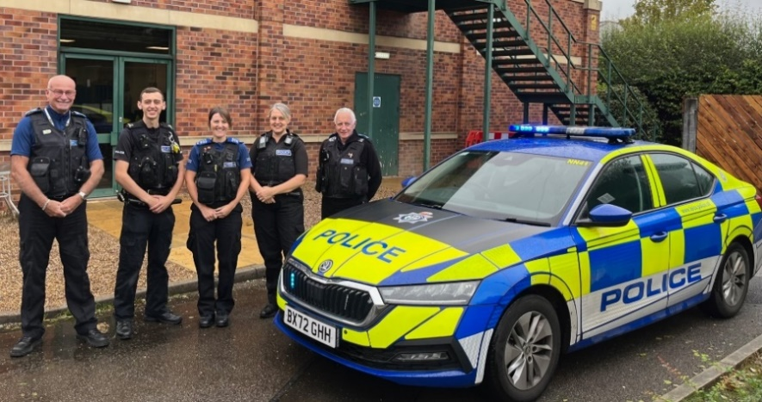

* PS 4107 Gary Sirrell
* PC 70 James Martindale
* PC 2238 Riannon Simpson
* PCSO 6517 Tony Gallagher
* PCSO 6178 Nicola Russell
* PCSO 6683 Pat McDonald

Your Dedicated Neighbourhood Team (DNT) is a group of local police officers dedicated to serving your community. The team is made up of officers based in your area, supported by the wider Policing family.

**What Matters to You**

Consultation via Neighbourhood Link, social media, local engagement events and from our assessment of emerging crime trends we will be now focusing on the following beat priorities - next review: March 2024.

***Priority 1:* Theft from motor-vehicles- Specifically targeting the new build estates.**

*You Said:* Vehicles are being broken into on New Build estates, specifically overnight.

*What we are going to do:* Conduct additional patrols in hotspot areas to deter criminality with the aim to catch and prosecute offenders.

***Priority 2:* To tackle the issue of thefts from HGVs in the Castle Donington area.**

*You Said:* Reports of goods vehicles targeted overnight by organised thieves.

*What we are going to do:* Increase patrols at known locations to deter this criminality with the aim of catching those responsible.

We will work with HGV drivers, local businesses to target harden locations, and to provide crime prevention advice and initiatives.

***Priority 3:* To tackle the issue of shop thefts in the Castle Donington and Kegworth areas.**

*You Said:* Stores staff/customers have reported a recent increase in shop lifting at village shops.

*What are we going to do:*  Conduct additional patrols at the stores to deter crime and catch those responsible.  
We will provide stores with crime prevention advice to help reduce the risk of crime.

**Page 1 Valley Newsletter**

**Introducing Leicestershire Police Pledge**

**Page 2**

Today Leicestershire Police has introduced a new public pledge to reaffirm its commitment to serve the people of Leicester, Leicestershire and Rutland.

Its aim is to set out clearly what the force does as an emergency service and where Leicestershire Police will continue to strengthen its service and raise standards.

The Pledge was developed by officers and staff with feedback from communities in Leicester, Leicestershire and Rutland.



Chief Constable Rob Nixon said: “I have introduced the Leicestershire Police Pledge to reaffirm the force’s steadfast commitment to good service and high standards. Our teams of officers, staff and volunteers step out day and night to protect our communities, detect and prevent crime. We want to be clear with the public about the service they can expect, from answering emergency calls to catching criminals, and focus on what matters.

“Nationally and locally the police are asked to do more and more while crime and prevention become more complicated. We want people to have confidence in the service we give which starts with being open and clear about what the force does and where we continue to improve and invest our resources.

“The Pledge sets out our duty and service as an emergency service. Obviously, it’s what we do that matters in a pledge and that is our focus. We want to stick to policing’s core role, what the public expect and want to see, and deliver it well and to high standards.”

**Crime Figures**

**To find out about crime that occurs within your area, please click on the link below.**

<https://www.police.uk/pu/your-area/leicestershire-police/valley/>

**Note: published crime and anti-social behaviour data will exceed 30 days old.**

The Valley beat has recently seen an increase in theft from Motor-vehicles, specifically targeting Castle Donington and the new build estates. It appears that opportunistic thieves are testing their luck by trying car and door handles, typically in the early hours of the morning.

Whilst we will be increasing visibility in affected areas and conducting routine patrols of known hotspots. It is important to remember the simple things that you can do, to prevent being an ‘easy target’.

Burglary Facts:

* Burglars target homes that they think will contain valuables. A sure giveaway is leaving packaging from expensive items outside your front door.
* Burglars often look for homes with windows or doors left open or with vulnerable features that they can exploit.
* Burglars are aware of the times when someone is expected to be away from their house such as during the school run or holidays. Consider changing your routine.
* Burglars typically do not want to be seen or heard and if they feel that they would be noticed by a neighbour or passer-by then they are more likely to feel exposed and may move on to find somewhere else to burgle.
* Burglars often choose a home because they’ve spotted a specific vehicle, motorcycle or bicycle they want to steal – and the keys are more than likely to be inside the residence.
* Sheds and garages are often vulnerable as they are not that secure and contain tools which the burglar can use to assist them to gain entry to a home.
* It’s a fact that many burglars return to homes that they’ve previously burgled because the homeowner failed to upgrade security following the first burglary. They sometimes return to an area to try to burgle a nearby home that they spotted while committing a previous break in. Even more reason for you to ensure you keep your home as safe as houses.

**Crime Trends**

**Page 3**

The car cruise is still an extremely hot topic. Each weekend the team are still deploying at least one marked Police vehicle with the intention to also deploy unmarked resources when staffing allows.

Over the last month the Police have received Four reports of vehicles racing. The majority of which have been situated on the A453 toward Moto-services.

Approximately 30 warning letters have been sent within the last month alone, three drivers have been investigated for racing on a public highway and are all awaiting court dates. Other drivers have also been issued Traffic offence reports for vehicle defects such as number plate issues and bold tyres.

This matter whilst ongoing is still being tackled.

**What we are doing**

This month we will be paying close attention to the beat priorities, using target hardening techniques to make it that little bit harder for criminals to take advantage.

The car cruise is clearly still persistent. To continue our dedicated work, we will be deploying marked and unmarked resources when staffing allows to continue reducing the impact that the offenders are having on you.

Speeding is still an issue particularly in the parish of Worthington. We will be working closely with the parish and local community to target speeding motorists. A date is to be set for a joint operation.

This month we will continue to work alongside local shops such as CO-OP, Market Place, Kegworth and Aldi Stores, Castle Donington to reduce criminal behaviour such as shoplifting. These locations are just a few that are targeted by petty thieves. NorthWest Leicestershire Officers recently arrested two suspects in relation to shop theft offences.



**Car Cruise **UPDATE\*\***

**Page 4**

**Page 5**

**Community Engagements**

**Page 3**

**Don’t miss out on our events:**

***Drop in session - Lockington/Hemington Village Hall***

* 1730 - 1830 hours, Wednesday 14th February 2024
* Hemington Lane, DE742RJ
* ,

DE742LA.

***Drop in session – Worthington store/Post Office***

* 1700 - 1800 hours, Friday 1st March 2024
* St Matthews Avenue, Worthington, LE651SH.

***Drop in session - Staunton Harold Garden Centre***

* 1200 – 1300 hours, Saturday 9th March 2024
* Staunton Harold Garden Centre. LE65 1RU

***Drop in session - Kegworth Library***

* 1400 - 1500 hours, Thursday 7th March 2024
* Kegworth Library, High street, DE742DA

***Drop-in session – Kegworth Baptist Church Café***

* 1000 - 1100 hours, Friday 12th April 2024
* Kegworth Baptist Church Café, High Street, DE74 2D

***Drop in session – Diseworth Heritage Centre***

* 1000 – 1100 hours, Wednesday 10th April 2024
* *Diseworth Heritage Centre, Ladygate, Diseworth, DE742QF*

**Contact us**

**NEIGHBOURHOOD LINK:**

Neighbourhood Link is a community messaging service from Leicestershire Police that provides news and information about policing activity or initiatives, crime prevention advice as well as major incidents affecting your area. In order to receive messages, you will need to register your details. Registration is free and simple to follow.

• Sign up at: <https://www.neighbourhoodlink.co.uk>

• Already have an account? Simply request a reminder if you have forgotten your username or password

• You can unsubscribe from the service at any time

Neighbourhood Link is not able to receive messages and you should not use it to contact the police. In an emergency always dial 999. If you wish to contact Leicestershire Police in other circumstances, for example to speak to local police or seek advice on police matters, you can call us by dialling 101 on your telephone or using any of the below sites.

Please also take the time to let the Valley Beat understand your concerns by completing the surveys to the right. Simply scan your camera over the top and click the link.



Your Views Survey



Confidence Survey

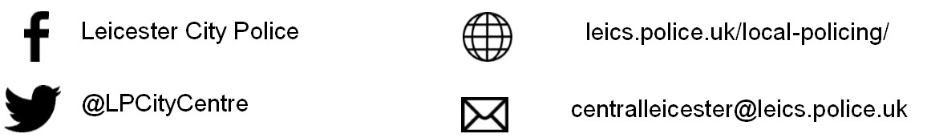

**@NWLeicsPolice**

**www.Leics.Police.uk**

**North West Leicestershire Police**

**Northwest.lpu@leicestershire.pnn.police.uk**