north west leicestershire VALLEY BEAt
Police update SePTEMBER 2022

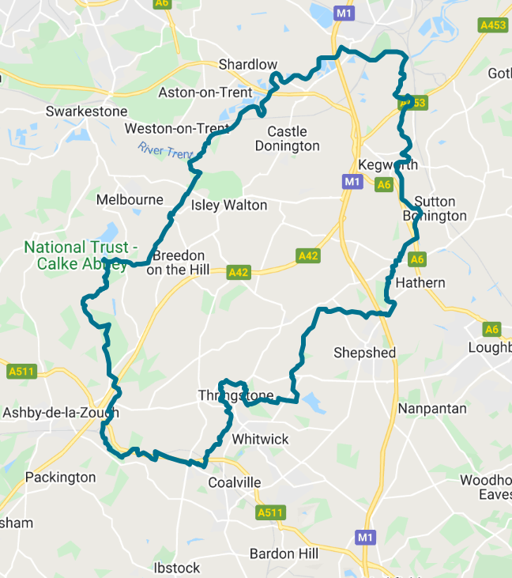
BEAT TEAM CONTACTS:

If you need to contact a member of your beat team and the enquiry isn’t urgent then the easiest way to do this is via Email, you can either do this through the Leicestershire
Police website or on the details below:

PC 70 Martindale – james.martindale1@leicestershire.pnn.police.uk
PC 1391 Coleman – adrian.coleman@leicestershire.pnn.police.uk
PCSO 6178 Russell – nicola.russell@leicestershire.pnn.police.uk
PCSO 6683 McDonald – patrick.mcdonald@leicestershire.pnn.police.uk

CRIME FIGURES: (please click the link to show the latest available crime figures in the Valley Beat Area)
https://www.police.uk/pu/your-area/leicestershire-police/valley/

VALLEY BEAT CRIME FIGURES FOR SEPTEMBER 2022:

Swannington Parish
08/09 - Criminal damage to bus by passengers Station Hill, Swannington.

Worthington/Newbold Parish
No reports

Belton Parish
No reports

Staunton Harold
No reports

Coleorton Parish
26/09 – Drugs cultivation, 6 mature cannabis plants located by officers in a greenhouse at The Moorlands, Coleorton.

Kegworth Parish

01/09 - Criminal Damage to front door committed Thomas Road, Kegworth.
03/09 – ASB motorbikes racing on public footpath, A6/Kegworth bypass to A453.
06/09 - Theft of trainers from work premises. Hall Farm Road, Kegworth.
09/09 - ASB pavement parking, Derby Road, Kegworth.
11/09 – Smoking use in dwelling, Pritchard Drive, Kegworth.
14/09 – Theft of catalytic converter from a vehicle, Wilders Way, Kegworth.
24/09 - Theft of a caravan, Heath Drive, Kegworth.
28/09 – Theft of a trailer from lay-by, London Road, Kegworth.
30/09 – Theft of money in dwelling, Thomas Road, Kegworth.
29/09 – Neighbour dispute, Brickyard Lane, Kegworth.

There have been numerous reports of organized car cruises on Sunday evenings at the A453 Kegworth to Moto Services dual carriageway. Marked Police vehicle patrols are underway to try to discourage this activity.
Osgathorpe Parish
13/09 – Animal activists camping and flying drones over a commercial site at Hillcrest Research Centre, Dodgeford Lane, Osgathorpe.

Castle Donington Parish
02/09 – Theft stores at the Co-op, Trent Lane, Castle Donington.
05/09 – Theft from motor vehicle, Castle Donington
08/09 – Drugs, cannabis use Diseworth Road, Castle Donington.
14/09 - Theft of cat convertor from vehicle, Wilders Way, Castle Donington
19/09 – Theft of cat convertor from vehicle, Hilton Hotel, Castle Donington.
19/09 - ASB noisy youths at bus stop Barn Close, Castle Donnington.
22/09 – Attempt theft from HGV Sills Road, Castle Donington.
22/09 - Theft of diesel from HGV, Sills Road, Castle Donington.
26/09 – RTC person struck by E-scooter, Delven Lane, Castle Donington.

Breedon on the Hill Parish
27/09 - Drugs possession per stop check at Breedon Church.

Hemington/Lockington Parish
No reports

Diseworth/Long Whatton Parish
15/09 – Parking dispute, Long Whatton

PLANNED BEAT SURGERIES:
Who’s going | Date & Time |  | Location | Event title
OCTOBER
PCSO 6178 Russell |  | Mon 3rd October @ 6.00pm x 7.00pm | St Hardulph's Primary School, Breedon. DE73 8AN | Cancelled as officer is unavailable.
PC 1391 Coleman  PC 70 Martindale |  | Tues 11th October @ 6.00pm x 7.00pm | Belton Village Hall, School Lane, LE12 9TU | Drop in session - Prior to PC Meeting
PCSO 6178 Russell  PCSO 6683 McDonald |  | Sat 29th October @ 11.00am x 1.00pm | Kegworth Village Hall. Nottingham Rd, DE74 2FH | Craft Fair - drop in session
NOVEMBER
PCSO 6178 Russell |  | Tues 8th November @ 6.00pm x 7.00pm | Osgathorpe PC, Harley Hall, Osgathorpe. LE12 9SY | Drop in session - Prior to PC Meeting
PC 1391 Coleman  PC 70 Martindale |  | Wed 16th Nov @ 6.00pm x 7.00pm | Beaumont Centre, Peggs Green. LE67 8HN | Drop in session - Prior to PC Meeting
PC 70 Martindale |  | Thurs 24th Nov @ 6.00pm x 7.00pm | Castle Donington Community Hub, DE74 2NH | Drop in session - Prior to PC Meeting
DECEMBER
PCSO 6178 Russell PCSO 6683 McDonald |  | Sun 4th December @ 1.00pm - 3.00pm | Kegworth Xmas Market. Market Place, Kegworth, DE74 2EE | Christmas Market - drop in session
PCSO 6178 Russell PCSO 6683 McDonald |  | Weds 14th December @ 10.00am to 12.00am | Heritage Centre, Ladygate Diseworth. DE74 2QF | Coffee morning – drop in session. To be confirmed
PCSO 6178 Russell PCSO 6683 McDonald |  | Thurs 22nd December @ 10.00am to 11.00am | Long Whatton Village stores,  Main Street, LE12 5DF | Drop in session outside shop. To be confirmed

BEAT TEAM OFFICER UPDATE:

PC 819 Harrison enjoyed serving the communities of the Valley Beat for the past four years and has now moved to a new challenge within Leicestershire Police. We wish Steve every success in his new role.

We now welcome PC 70 James Martindale to the beat, he brings a wealth of policing experience and enthusiasm to the role. James is looking forward to making a difference in the communities of the Valley Beat.

PC 70 MARTINDALE

OFFICERS OF THE VALLEY BEAT TEAM:

PS 1341 LEELAND

PC 1391 COLEMAN PC 70 MARTINDALE

PCSO 6178 RUSSELL PCSO 6683 MCDONALD

Please come along for a chat to a beat surgery which are scheduled for 2022 per the calendar attached. We are always happy to listen to your concerns/comments and to offer help/advice.

NEWS
Her Majesty The Queen

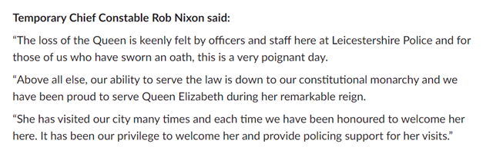

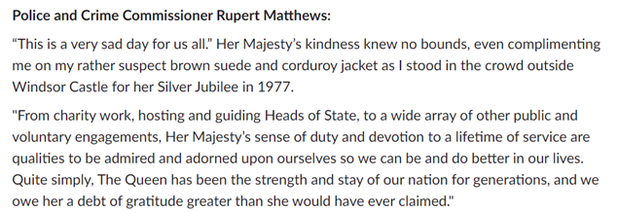

NEIGHBOURHOOD LINK:

Neighbourhood Link is a community messaging service from Leicestershire Police that provides news and information about policing activity or initiatives, crime prevention advice as well as major incidents affecting your area.
Through this service you can receive messages from your local Neighbourhood Policing Team, local police or, in the event of a major incident or event affecting the whole of Leicestershire, from a partnership of agencies known as the Local Resilience Forum.

In order to receive messages, you will need to register your details. Registration is free and simple to follow.

• Sign up to Neighbourhood Link https://www.neighbourhoodlink.co.uk/
• If you are already registered you can amend your details
• Request a reminder if you have forgotten your username or password
• You can unsubscribe from the service at any time

Neighbourhood Link is not able to receive messages and you should not use it to contact the police. In an emergency always dial 999. If you wish to contact Leicestershire Police in other circumstances, for example to speak to local police or seek advice on police matters, you can call us by dialling 101 on your telephone.

