north west leicestershire VALLEY BEAt
Police update JANUARY 2023

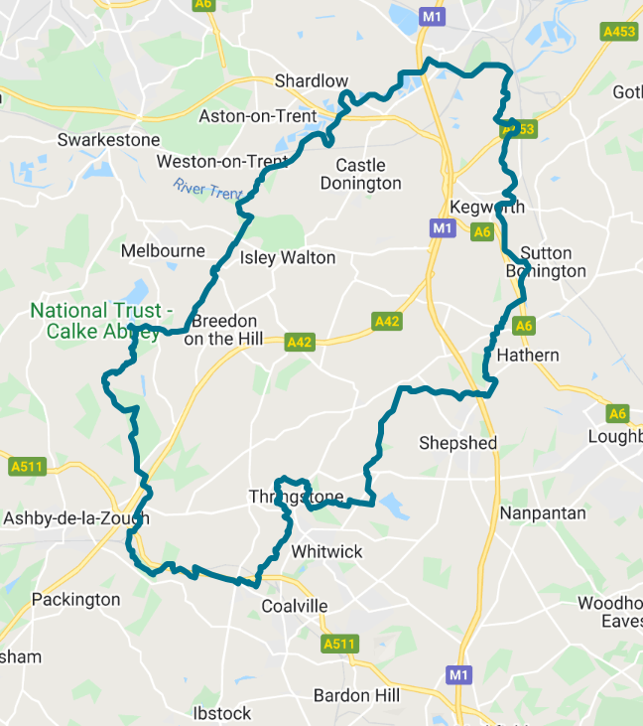
BEAT TEAM MEMBERS

PS 1341 Leeland
PC 70 Martindale
PCSO 6178 Russell
PCSO 6683 McDonald
PCSO 6517 Gallagher

REPORTING A CRIME

Please report an incident/crime on 101 for non-emergency or 999 in an emergency.

Did you know you can report crime and incidents using our online portal.
Please visit https://www.leics.police.uk/
Click on REPORT.

CRIME FIGURES

(please click the link to show the latest available crime figures in the Valley Beat Area)
https://www.police.uk/pu/your-area/leicestershire-police/valley/

Car cruise A453 – Update

The last organised car cruise occurred on the A453 Kegworth EMG to Moto and at Arundel Avenue, Castle Donnington on the evening of Saturday 14th January 2023. Officers attended both locations dispersing participating vehicles out of the county.

VALLEY BEAT CRIME FIGURES FOR JANUARY 2023

Belton Parish
27/01 - Theft stores.

Breedon on the Hill Parish
26/01 – Criminal damage to window.

Castle Donington Parish
02/01 – Criminal damage to plants.
03/01 – Theft of motorcycle.
04/01 – Attempt Theft of motor vehicle.
04/01 – Theft of mobile phone.
04/01 – Theft of tools from van.
06/01 – Theft of pallets from HGV.
07/01 – Public disorder Moto.
08/01 – Criminal damage to vehicle.
10/01 – Theft of cat converter.
14/01 – Theft stores (Borough).
17/01 – Theft of pallet from HGV.
18/01 – Theft fuel Moto x 2.
18/01 – Theft of purse EMA hotel.
19/01 – Theft of pallet from HGV.
22/01 – Criminal damage to window.
23/01 – Theft stores Co-op.
23/01 – Vehicle interference.
25/01 – Theft of cargo from HGV.
29/01 – Theft fuel Moto.
29/01 – Theft stores Co-op.
31/01 – Theft of fuel Moto.

Cavendish Bridge Parish/Sawley
16/01 – Attempt theft from motor vehicle.

Coleorton Parish
11/01 – Burglary (shed).
26/01 – Miscellaneous dog v dog attack.

Diseworth/Long Whatton Parish
03/01 – Theft of diesel HGV A42.
10/01 – Theft of cat converter.
18/01 – Theft of diesel HGV A42.
23/01 - Theft of diesel HGV A42.
31/01 – Theft of diesel HGV A42.

Hemington/Lockington Parish
04/01 - Burglary residential.
19/01 - Theft of diesel from machinery.

Kegworth Parish
05/01 – Criminal damage to vehicle.
06/01 – Theft of a sign.
07/01 – Public disorder.
09/01 – Theft of motor vehicle.
11/01 – Theft stores Co-op.
12/01 – Criminal damage to gate.
18/01 – Theft stores Co-op.
20/01 – Theft stores Co-op.
28/01 – Theft stores Co-op.
31/01 – Theft watch Yew Lodge.

Osgathorpe Parish
28/01 – Criminal damage to crops.

Staunton Harold Parish
No reports.

Swannington Parish
No reports.

Worthington / Newbold Parish
24/01 – Attempt theft from vehicle.
24/01 – Theft of tools from vehicle.

MINI COPS
Mini Police is an innovative and fun police engagement programme, which is delivered in schools with the support of Police Community Support Officers (PCSOs) from the local neighbourhood police team.

The aim of Mini Police is to provide school children in Year 5 (age 9 and 10) with a fun and interactive way to introduce children to a positive experience of policing and to get them involved in the local community.
Our Mini Police programme aims to:
- Introduce policing as a positive influence to children
- Build relationships, trust and confidence in children
- Nurture feelings of social and moral responsibility, safety, and policing through a fun and engaging programme of activities

- Encourage children to positively engage with their local community policing team
- Reduce their risk of becoming offenders or victims
- Work together with partners to begin to instil age-appropriate safety-awareness
The programme revolves around a framework of:
- Police led education - This being an educational input which will cover issues identified in partnership with the school and will involve current priorities and areas for concern e.g. road, fire, water safety, knife crime, internet safety etc.
- School led community engagement – A community action carried out by the children to include local priorities e.g. litter picking, parking awareness outside school, speeding etc.
- Reward – This is a means of thanking the Mini Police for carrying out the above elements e.g. a visit to a police station or specialist unit (Dogs/Control Room), a visit to a fire station etc.

Two PCSOs and five Year 5 students at the launch of Mini Police
The Mini Police programme will be held during the school day and align with the school academic year providing consistent engagement and enabling officers, schools and partners to work together.
The Mini Police programme links in with the statutory Key Stage 2 requirements of Personal, Social, Health and Economic (PSHE) education, enabling schools to focus on the children’s personal development, helping them be more confident, resilient, independent and develop character.

Register your interest
The Mini Police scheme is currently being piloted by three primary schools in Leicestershire. Pending the outcome of a review of the pilot due in summer 2023, we hope to be in a position to offer Mini Police to further schools.
If you would like to register your school's interest in Mini Police, please complete our register of interest form and a member of our team will be in touch with you in due course.
PCSO Fowkes and a PS Waka delivering Mini Police to Year 5 students

CRIME PREVENTION

Lock it, hide it or mark it

Don’t give them the opportunity or the tools to commit a crime. Lock everything away securely. Tools can be locked inside a locker or box or secured with a chain. Secure your bike to the ground or a lockable stand within a locked shed or garage.

Visit Sold Secure to search for ground anchors and other locks designed to fix to floors and walls. It’s always worth draping an old sheet or blanket over the top of mowers or bikes to keep them covered from view. Although it might sound like stating the obvious, never leave your garage or shed door unlocked if you’re not around. Property marking your items is advisable and some tools can be painted with your name or postcode. Forensic marking is also an option.

Darker nights

Now we are experiencing longer/darker winter nights please ensure you are extra vigilant in relation to vehicle, home and personal security.

Crime prevention tips and advice can be found on the Leicestershire Police website using the link attached below.

https://www.leics.police.uk/cp/crime-prevention/

BEAT SURGERIES 2023

Who’s going |  | Date & Time | Location | Event title
FEBRUARY 23
PCSO 6178 Russell  PCSO 6683 McDonald | Wednesday 8th February @ 10.00am to 12.00pm |  | Diseworth Heritage Centre, Ladygate, Diseworth, DE74 2QF | Coffee morning – drop in session
PCSO 6178 Russell  PCSO 6683 McDonald | Wednesday 15th February @10.00 to 11am |  | Castle Donington CO-OP Station Road, Castle Donington DE74 2NJ | Drop in session outside the entrance
PCSO 6178 Russell  PCSO 6683 McDonald | Thursday 23rd February@  10.00am to 12.00pm |  | Kegworth CO-OP, Market Place,  Kegworth, DE74 2EE | Drop in session outside shop
MARCH 23
PCSO 6178 Russell  PCSO 6683 McDonald | Wednesday 8th March @12:00 to 13:15pm |  | Kegworth Village Hall, Nottingham Road, Kegworth DE74 2RH | Drop in session at the Soup and Sweet lunch club
PCSO 6178 Russell  PCSO 6683 McDonald | Sunday 12th March @ 13.00 to 15.00pm |  | Staunton Harold Garden Centre, Staunton Harold. LE65 1RH | Drop in session outside the Centre entrance
PCSO 6178 Russell  PCSO 6683 McDonald | Friday 31st March @ 14.30 to 15.30pm |  | St Edwards C of E Primary School. Dovecote, Castle Donington DE74 2LH | Drop in session outside school gates
APRIL 23
PCSO 6178 Russell  PCSO 6683 McDonald  PCSO 6517 Gallagher | Thursday 13th April @ 08.30 to 09.30am |  | Hemington Primary School, Main Street, DE74 2RB | Drop in session outside school gates
PCSO 6178 Russell  PCSO 6683 McDonald | Wednesday 27th April @ 10.00am to 12.00pm |  | The Moorlands, Coleoton, LE67 8GA | Patch Walk with NWLDC

Please feel free to pop along to one of our a 2023 beat surgeries per the above calendar. We are happy to listen to your concerns/comments and to offer practical help and advice.

VALLEY BEAT TEAM

PS 1341 LEELAND | PC 70 MARTINDALE
PCSO 6517 GALLAGHER | PCSO 6178 RUSSELL | PCSO 6683 MCDONALD
NEIGHBOURHOOD LINK
Neighbourhood Link is a community messaging service from Leicestershire Police that provides news and information about policing activity or initiatives, crime prevention advice as well as major incidents affecting your area.
Through this service you can receive messages from your local Neighbourhood Policing Team, local police or, in the event of a major incident or event affecting the whole of Leicestershire, from a partnership of agencies known as the Local Resilience Forum.
In order to receive messages, you will need to register your details. Registration is free and simple to follow.

• Sign up to Neighbourhood Link https://www.neighbourhoodlink.co.uk/
• If you are already registered you can amend your details
• Request a reminder if you have forgotten your username or password
• You can unsubscribe from the service at any time

Neighbourhood Link is not able to receive messages and you should not use it to contact the police. In an emergency always dial 999. If you wish to contact Leicestershire Police in other circumstances, for example to speak to local police or seek advice on police matters, you can call us by dialling 101 on your telephone.

