north west leicestershire VALLEY BEAt
Police update February 2023

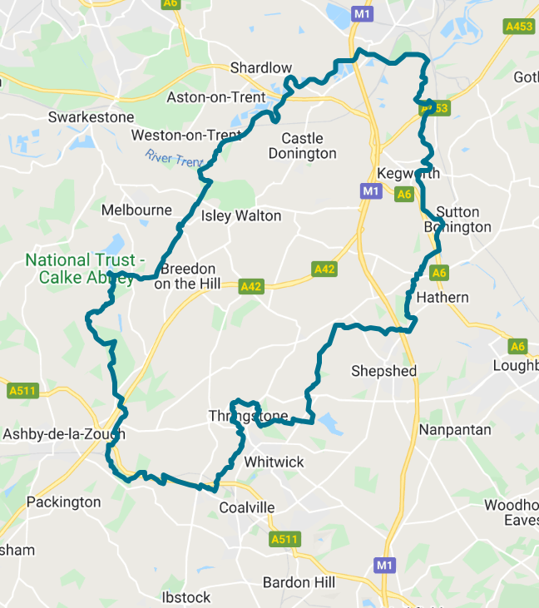
BEAT TEAM MEMBERS

PS 1341 Leeland
PC 70 Martindale
PCSO 6178 Russell
PCSO 6683 McDonald
PCSO 6517 Gallagher

REPORTING A CRIME

Please report an incident/crime on 101 for non-emergency or 999 in an emergency.

Did you know you can report crime and incidents using our online portal.
Please visit https://www.leics.police.uk/
Click on REPORT.

CRIME FIGURES

(please click the link to show the latest available crime figures in the Valley Beat Area)
https://www.police.uk/pu/your-area/leicestershire-police/valley/

Car cruise A453 – Update

The last organised car cruise on the Valley beat occurred at the A453 Kegworth EMG on the evening of Sunday 12th February 2023. Frequency of incidents has reduced since the start of 2023.

VALLEY BEAT CRIME AND ASB FIGURES FEBRUARY 2023

Belton Parish
No reports.

Breedon on the Hill Parish
02/02 – ASB suspect males trying car doors Main Street.
02/02 – Theft building products from site Ashby Road.
04/02 – Theft x 4 of cash from lockers Priory Health Club, Wilson.
16/02 – Theft from van (tools) Main Street.

Castle Donington Parish
02/02 – Robbery/theft HGV (car tyres) Sycamore Road.
04/02 – Bilking fuel Moto Services.
05/02 – Bilking fuel Moto Services.
06/02 – Bilking fuel Moto Services.
07/02 – ASB suspect males Hastings Street.
09/02 – ASB suspect males St Edwards Road.
10/02 – Theft x 2 of cat converter EMA Hilton.
11/02 – Theft of cat converter EMA Hilton.
13/02 – Criminal damage (scratch) motor vehicle Delven Lane.
17/02 – Bilking fuel Moto Services.
21/02 – Theft HGV freight Moto Services.
22/02 – Theft mobile phone Market Place.
22/02 – Attempt fraud Available Car.
27/02 – Criminal damage to padlock Maple Road.

Cavendish Bridge Parish/Sawley
03/02 – Theft from motor vehicle Sawley Marina.

Coleorton Parish
No reports.

Diseworth/Long Whatton Parish
01/02 – Theft of diesel from HGV A42.
01/02 – Criminal damage to motor vehicle Main Street.
04/02 – Theft from small holding/caravan Ashby Road.
06/02 – Public order object thrown at vehicle Mill Lane.
12/02 – Burglary (business) Walnut Yard.
23/02 – Theft of diesel from HGV A42.
28/02 – Public Order Turvey Lane.

Hemington/Lockington Parish
04/02 – ASB motorbikes Warren Lane.
05/02 – Theft/damage Lockington quarry.
14/02 – Attempt theft from van Station Road.

Kegworth Parish
03/02 – Theft stores Co-op.
07/02 – Theft stores x 2 Co-op.
11/02 – Theft stores Co-op.
15/02 – ABH road rage Nottingham Road.
19/02 – Public order Sutton Road.
21/02 – Theft stores Co-op.
26/02 – Theft stores Co-op.
26/02 – Threats to damage Pritchard Drive.
26/02 – Public order Computer Centre Packington Hill.
26/02 – Threats to staff Computer Centre Packington Hill.
27/02 – Misc obstruct officer A6 Derby Road.
27/02 – ABH assault PC A6 Derby Road.
28/02 – Criminal damage Computer Centre Packington Hill.
28/02 – Burglary Computer Centre Packington Hill.
28/02 – Criminal damage graffiti Yew Lodge.
28/02 – ABH (push) riverbank Long Lane.
28/02 – Attempt burglary Computer Centre Packington Hill.
28/02 – Theft of number plates from vehicle Mill Lane.

Osgathorpe Parish
14/02 – Public order (neighbours) Main Street.
20/02 – ASB (neighbours) Chapel Lane.

Staunton Harold Parish
No reports.

Swannington Parish
No reports.

Worthington / Newbold Parish
09/02 ASB in the street Main Street.
13/02 – Criminal damage Pipeworks Lane.

CRIME PREVENTION

Lock it, hide it or mark it

Don’t give them the opportunity or the tools to commit a crime. Lock everything away securely. Tools can be locked inside a locker or box or secured with a chain. Secure your bike to the ground or a lockable stand within a locked shed or garage.

Visit Sold Secure to search for ground anchors and other locks designed to fix to floors and walls. It’s always worth draping an old sheet or blanket over the top of mowers or bikes to keep them covered from view. Although it might sound like stating the obvious, never leave your garage or shed door unlocked if you’re not around. Property marking your items is advisable and some tools can be painted with your name or postcode. Forensic marking is also an option.

Darker nights

Now we are experiencing longer/darker winter nights please ensure you are extra vigilant in relation to vehicle, home and personal security.

Crime prevention tips and advice can be found on the Leicestershire Police website using the link attached below.

https://www.leics.police.uk/cp/crime-prevention/

SPRING IS HERE!

The arrival of Spring brings the end of winter with nice temperature change, more daylight, the return of birds from winter vacation, bringing growth to plants and trees with the important arrival of baby animals greeting the world.

LAMBING SEASON and Our “Best Friend”

With lambing season upon us, dog walkers and owners need to take extra care when out and about within the countryside.
Around 16 million lambs are born in the UK every year, resulting in January to April being one of the busiest times in the whole farming calendar. Sadly however, the number of attacks on livestock has increased and consequently many sheep are being attacked, injured or killed.

- The presence of dogs, even with playful intent, can cause great anxiety within a flock of sheep.
- In lambing season, it is the main cause of stillbirths and miscarriages, which can occur 2-3 days after contact with dogs.
- What dog owners might not be aware of, is that new legislation has come into force since the last lambing season, which is designed to enhance the protection of all livestock with increased fines and the potential for custodial sentences (and I don’t mean the dog).
“It is the owner’s responsibility to keep their dog under control and we are also raising awareness about the potential consequences of not doing so. Livestock worrying is a criminal offence and a fine of £1,000 can be handed out.
As described by the Dogs (Protection of Livestock) Act 1953, the worrying of livestock by dogs is illegal and, of course, is of great concern to farmers for many obvious reasons. The word worrying in this context means the attacking or chasing of livestock in such a way that could result in injury, suffering, abortion or loss of produce.

Similarly, a dog being at large, in a field where there are sheep (which includes a dog not being kept on a lead or being kept under close control) may also be considered a breach of this act.

Dog walkers’ responsibilities
- do keep your dog on a lead and under your strict control

- ensure your dog is docile and obedient

- don’t allow your dog to chase or take an interest in sheep – or cute lambs!

- do be in charge and have full control at all times

- train your dog not to be aggressive when around sheep

- don’t be complacent – and stay alert at all times!

Remember, under the Dangerous Dogs Act 1991, dog owners may face prosecution (often resulting in severe penalties) and also a dog may sadly be shot, if it is found to be chasing a farmer’s livestock!

Well, we trust that the above information may be of some benefit to you and we wish all of our four-legged friends, dog walkers and farmers alike a very pleasant and enjoyable time outdoors, wherever you may be!

BEAT SURGERIES 2023

Who’s going |  | Date & Time | Location | Event title
MARCH 23
PCSO 6178 Russell  PCSO 6683 McDonald | Wednesday 8th March @12:00 to 13:15pm |  | Kegworth Village Hall, Nottingham Road, Kegworth DE74 2RH | Drop in session at the Soup and Sweet lunch club
PCSO 6178 Russell  PCSO 6683 McDonald | Sunday 12th March @ 13.00 to 15.00pm |  | Staunton Harold Garden Centre, Staunton Harold. LE65 1RH | Drop in session outside the Centre entrance
PCSO 6178 Russell  PCSO 6683 McDonald | Friday 31st March @ 14.30 to 15.30pm |  | St Edwards C of E Primary School. Dovecote, Castle Donington DE74 2LH | Drop in session outside school gates
APRIL 23
PCSO 6178 Russell  PCSO 6683 McDonald | Saturday 1st April @1000am - 1200pm |  | Sawley Marina, Sawley, NG10 3AE | Drop in session
PCSO 6178 Russell  PCSO 6683 McDonald  PCSO 6517 Gallagher | Thursday 13th April @ 08.30 to 09.30am |  | Hemington Primary School, Main Street, DE74 2RB | Drop in session outside school gates
PCSO 6178 Russell  PCSO 6683 McDonald | Wednesday 27th April @ 10.00am to 12.00pm |  | The Moorlands, Coleoton, LE67 8GA | Patch Walk with NWLDC
MAY 23
PCSO 6178 Russell  PCSO 6683 McDonald | Friday 5th May @1700-1800pm |  | Worthington Post Office, St Matthews Avenue, LE65 1SH | Drop in session outside of store

Please feel free to pop along to one of our a 2023 beat surgeries per the above calendar. We are happy to listen to your concerns/comments and to offer practical help and advice.

VALLEY BEAT TEAM

PS 1341 LEELAND | PC 70 MARTINDALE
PCSO 6517 GALLAGHER | PCSO 6178 RUSSELL | PCSO 6683 MCDONALD
NEIGHBOURHOOD LINK
Neighbourhood Link is a community messaging service from Leicestershire Police that provides news and information about policing activity or initiatives, crime prevention advice as well as major incidents affecting your area.
Through this service you can receive messages from your local Neighbourhood Policing Team, local police or, in the event of a major incident or event affecting the whole of Leicestershire, from a partnership of agencies known as the Local Resilience Forum.
In order to receive messages, you will need to register your details. Registration is free and simple to follow.

• Sign up to Neighbourhood Link https://www.neighbourhoodlink.co.uk/
• If you are already registered you can amend your details
• Request a reminder if you have forgotten your username or password
• You can unsubscribe from the service at any time

Neighbourhood Link is not able to receive messages and you should not use it to contact the police. In an emergency always dial 999. If you wish to contact Leicestershire Police in other circumstances, for example to speak to local police or seek advice on police matters, you can call us by dialling 101 on your telephone.

