north west leicestershire VALLEY BEAt
Police update APRIL 2023

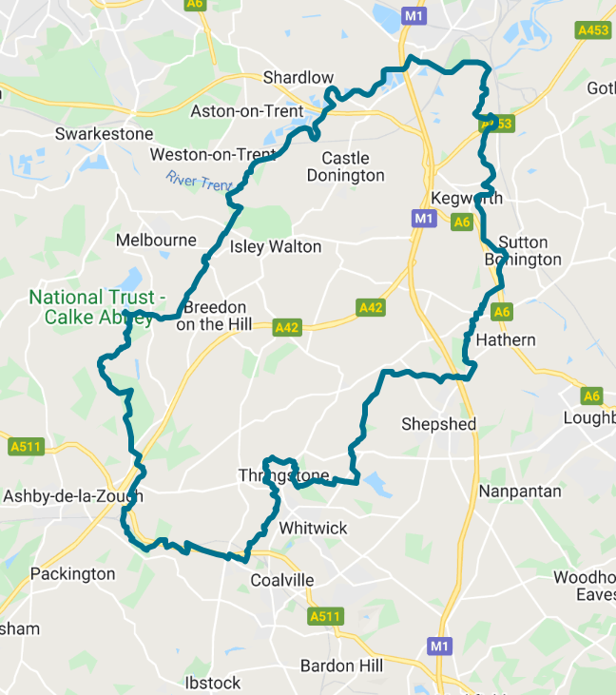
BEAT TEAM MEMBERS

PS 4107 Sirrell
PC 70 Martindale
PC 1794 Lockley
PCSO 6178 Russell
PCSO 6683 McDonald
PCSO 6517 Gallagher

REPORTING A CRIME

Please report an incident/crime on 101 for non-emergency or 999 in an emergency.

Did you know you can report crime and incidents using our online portal.
Please visit https://www.leics.police.uk/
Click on REPORT.

CRIME FIGURES

(please click the link to show the latest available crime figures in the Valley Beat Area)
https://www.police.uk/pu/your-area/leicestershire-police/valley/

Car cruise A453 – Update

The last organised car cruise on the Valley beat occurred at the A453 Kegworth EMG on the evening of Monday 1st May 2023 on A453. Incident frequency has increased.

VALLEY BEAT AQUISITIVE CRIME AND ASB FIGURES APRIL 2023

Belton Parish
No reports

Breedon on the Hill Parish
03/04 Theft of vehicle wheels

Castle Donington Parish
01/04 Criminal damage to window (flat)
06/04 Theft from HGV Moto
07/04 Theft stores Moto
09/04 Burglary to roadside café
10/04 Criminal damage to bus stones thrown.
10/04 Theft of tools from van
12/04 Theft of goods from HGV Moto
15/04 Distraction Burglary (residential)
20/04 Theft of vehicle keys Moto
22/04 Theft of mobile phone (bus)
25/04 Theft of mobile phone Moto
28/04 Criminal damage garden
29/04 Theft stores Co-op

Cavendish Bridge Parish/Sawley
No reports

Coleorton Parish
No reports

Diseworth/Long Whatton Parish
06/04 Theft of fuel from HGV
14/04 Distraction burglary residential
20/04 Threats to commit Criminal Damage
20/04 Attempt theft from HGV A42
27/04 Theft of fuel from HGV A42
27/04 Burglary to outbuilding

Hemington/Lockington Parish
15/04 Attempted theft from motor vehicle
16/04 Theft of tools from van
25/04 Theft of fuel from HGV
25/04 Theft of Portaloo

Kegworth Parish
04/04 Criminal damage (dog)
07/04 Theft/fraud mobile phone
08/04 Theft stores
09/04 Theft stores
13/04 Criminal damage to window
16/04 Theft stores
18/04 Theft stores
20/04 Theft stores x 3
26/04 Criminal damage chain RBS centre.
27/04 Theft of fuel from HGV
29/04 Theft stores
29/04 Theft of portacabin RBS centre.
29/04 Burglary dwelling
30/04 Criminal damage

Osgathorpe Parish
No reports

Staunton Harold Parish
No reports

Swannington Parish
14/04 Criminal damage PH windows
29/04 Theft garden items

Worthington / Newbold Parish
06/04 Criminal damage to fence
24/04 Theft plant pot

CRIME PREVENTION

https://www.leics.police.uk/cp/crime-prevention/

What is distraction burglary?

Distraction burglary is when a person tries to gain access to your home by trying to trick you into believing they need help or are officials in the area. Very often they will operate in pairs so one attempts the distraction whilst the other one takes the opportunity to steal things in the home.

The advice is not to let anyone into your home unless you are expecting them or know them. Even if you are expecting callers from a utility company or local authority, set a password when you make the arrangements that the caller has to give on arrival.

Use a door chain if possible whilst you establish the caller is genuine. Some common distraction burglary tactics are,

• Asking to use your phone as they have broken down. Wanting to help people is understandable but don’t let people in, once they are in it could be that their accomplice gains access whilst you are helping them. If you want to help, don’t let them in but offer to call a breakdown company.

• Pretending to be from a gas company saying there is a problem in the area. Understandably this can cause concern if you think there is a problem, but contact the gas company to find out if this is true.

Don’t use the contact number the caller gives you, use an official number, one from your bill. Check with a neighbour if you are concerned.

• Pretending to be from the water company saying there is a problem in the area. By saying there is a problem and asking you to run the taps in your home the distraction burglar is sending you into your bathroom or kitchen where you may not be able to see what they are doing. Don’t let them in and call your water company to check if this is a genuine problem.

• Pretending to be Police Officers or Trading Standards Officers.

Distraction burglars have been known to present themselves as officials. Again, do not let them in. Contact your local police office or Trading Standards office to check if these officers are genuine.

For advice contact Citizens Advice consumer helpline: 03454 04 05 06

Call the police 999 if you feel at risk or are concerned for a neighbour.

BEAT SURGERIES 2023

Who’s going |  | Date & Time | Location | Event title
MAY 23
PCSO 6178 Russell  PCSO 6683 McDonald | Friday 5th May @17.00-18.00pm |  | Worthington Post Office, St Matthews Avenue, LE65 1SH | Drop in session outside of store
PCSO 6178 Russell  PCSO 6683 McDonald | Wednesday 31st May @14:30-15.30pm |  | Breedon Shop, Main Street, Breedon, DE73 8AP | Drop in session outside store
JUNE 23
PCSO 6178 Russell PCSO 6683 McDonald | Thursday 1st June @ 1000am – 1115am |  | St Matthews Church, Church Street, Worthington, LE651RE | Church cafe
PCSO 6178 Russell  PCSO 6683 McDonald | Monday 12th June @ 1030am - 12noon |  | Falcon Inn, Main Street, Long Whatton | Coffee morning
PCSO 6178 Russell PCSO 6683 McDonald PCSO 6517 Gallagher | Wednesday 29th June @ 1000am - 1200pm |  | Bosworth Road, Castle Donington, DE74 | Patch Walk with NWLDC

Please feel free to pop along to one of our a 2023 beat surgeries per the above calendar. We are happy to listen to your concerns/comments and to offer practical help and advice.

VALLEY BEAT TEAM

PS 4107 SIRRELL | PC 70 MARTINDALE | PC 1794 LOCKLEY
 |  | 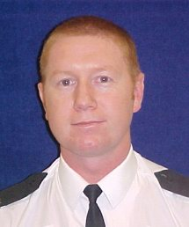
PCSO 6517 GALLAGHER | PCSO 6178 RUSSELL | PCSO 6683 MCDONALD
NEIGHBOURHOOD LINK
Neighbourhood Link is a community messaging service from Leicestershire Police that provides news and information about policing activity or initiatives, crime prevention advice as well as major incidents affecting your area.
Through this service you can receive messages from your local Neighbourhood Policing Team, local police or, in the event of a major incident or event affecting the whole of Leicestershire, from a partnership of agencies known as the Local Resilience Forum.
In order to receive messages, you will need to register your details. Registration is free and simple to follow.

• Sign up to Neighbourhood Link https://www.neighbourhoodlink.co.uk/
• If you are already registered you can amend your details
• Request a reminder if you have forgotten your username or password
• You can unsubscribe from the service at any time

Neighbourhood Link is not able to receive messages and you should not use it to contact the police. In an emergency always dial 999. If you wish to contact Leicestershire Police in other circumstances, for example to speak to local police or seek advice on police matters, you can call us by dialling 101 on your telephone.

